**Pastor Jeff’s Notes: Analog in a Digital World.**

Ah, for the **old days**! I tend to think that life was so much simpler when phones had cords, and people had to call you back if you weren’t home. Cars could be worked on the backyard and team sports never practiced on Sundays. I remember when a mistake typing could be corrected with a with a little paint brush, but I usually bought “onion paper” which was slick enough I could erase letters with a rubber eraser and then type the correct letter. Copies were made using carbon copies attached to your original and run into the typewriter.

For some people, we’d rather that our phones are not smart, Alexa is only a cute baby’s name, and cookies are just coming out of the oven. Analog means picture tubes once gave light to our televisions, and streaming required waders and a fishing pole. But the world has moved on. Society is largely digital, fast-paced, confusing and unpredictable. How do we serve Christ and serve the world in His name, with all these challenges and changes? I have seen and heard two Christian approaches: ***hunker down*** and ***adapt***, for the sake of the gospel.

**To hunker down means** the church will dig in and outlast the onslaught of culture wars, value challenges and even the information age. Here are some ways we think when we hunker down: Since our message is timeless, we believe the methods of conveying it need not change either: if it was good enough for our forefathers, it is good enough for us. As Christian’s sabbath day, Sunday is reserved for church and nothing else. Children need to read their bible and act in Christmas pageants, sit through worship by a certain age and respect their elders by not interrupting them, letting them call all the shots and helping them cross the street. Old hymns are better than modern ones and popular music is seen as a threat. The main theme of this kind of church is “survive.”

**To adapt means** the church will act out of the great commission to “Go and make disciples of all nations,” which means most ministry will take place outside the building. Here are some ways we think when we adapt: Since our message is timeless, we trust that God can speak it in different ways for different applications. The methods of spreading the good news of God’s love change to meet the needs of today and tomorrow. The Christian Sabbath day changed the meaning from rest to celebration, thus the Sunday worship service reflects mainly joy and thanks to God for believers, not a vehicle to draw people into the faith. We bring the faith message with our bibles to the places people live and work and play, and our music reflects the gospel in modern tones. The main theme of this kind of church is “engage the world.”

Serving eight years as superintendent, I have seen both kinds of churches as well as some which were making the transition from hunker to adapt. Where do you think we are as a church? Where is God calling us to be in our theme of living the gospel? Are we analog or digital?

Our **Church Council** will be working hard to institute changes in 2025 to engage the world more effectively for sake of Christ. We will discern how to adapt our mission and ministries to grow disciples of Christ, and we will focus less on reliving what we did in the past. We will work to align all our ministries with our mission, and this will be reflected in our building use, the focus of our services (outside versus inside) and how decisions get made. We will consolidate efforts so people can spend less time managing the organization and more time empowering people to serve God based on their spiritual gifts. Look for some **adaptations** coming soon this year, and please don’t hesitate to give input to the members of our Council going into 2025.

**Parish Visitor/Cindy Ellis**

Here we are at the end of the year. I thank you for supporting my position as parish visitor.

I visited many of our church families in person or by phone and enjoyed each visit. I am so thankful for all who visit our members. We are a caring, loving, congregation. And so, we continue to remember those who are ill or recovering from surgery, hospital stays, etc. Nancy Kallenborn, Dick Brigger, Hope Mayhew, Guerry Austin, Joe Thresher, baby C.J. Woodard, Jean Paul Larry Walter, Alan Madison, Betsy Hull and Andrea Haradon, Dan Flatt, Denise Hamilton, Marion Avery, Gayler Perreault, Dan Ryan, Mary Smith – Others needing our prayers and cards are Kevan Carichner, Barb & Don Sommers, Dick Davies, Betty Hess, Letha Padgett, Josie Knapp, Beverly Ring, Phyllis Naegely, Carl Schnautz, Bonnie Flashphaler, Mary Mack, Carol Erway, Gladys Kucher, Dolores Wilcox, Tom Peck, Lucille Panosian, Nancy Whitaker, Anne Bargesser, Evelyn Catlin, Bob Blackall. Let us keep Phil and Ida Beard in your prayers on the passing of Phil’s

brother-in-law Charles Pittman. Love and peace to all in 2025.

**Would you be interested in engaging in activities during the lengthy, chilly days of winter?**

As we welcome a new year, it is important to practice self-kindness. We have an array of wonderful opportunities to assist you in doing just that.

1. Beginning Wednesday, January 8: Tai Chi sessions tailored for seniors. Join us at 10 AM every Wednesday for a simple 20-minute routine designed to enhance your balance.

2. On Monday, January 20, at 1 PM, we will host a BOOK CLUB. Please contact me for the selection of the book for January.

3. Join us every Friday from noon to 2 PM for GAMES, including EUCHRE and various board games. You are welcome to bring your own games or use ours. Feel free to bring a sandwich; coffee and tea will be provided.

We hope to see you at one or all of these enjoyable events! Should you have any questions, please reach out to me, Louise, at 607-739-1954.

**Investment Committee:** On January 1st of 2024, 38 years after its establishment in 1986, our Church’s Living Endowment Fund had total contributions (principal) of $227,002 and transferred $277,522 to the Church’s operating budget. The market value of the fund was $334,024. The Investment committee approved an additional transfer of $17,000 to our Church’s operating 2024 operating fund. This transfer brought total transfers to $294,522 for our Church over the life of the fund. During 2024, as of the end of October, additional contributions to the Living Endowment Fund were $1,186. As of the end of November 2024, the market value of our Living Endowment Fund at Morgan Stanley was $385,435. It looks now, if the market value holds, that the fund will be able to transfer more than $17,000 to our Church’s 2025 operating fund. The bylaws of the Living Endowment Fund limit transfers to 5% of the fund’s market value on Jan 1st. Also, the bylaws do not allow invasion of the principal.

**Stewardship:** Although the numbers for 2024 have not been finalized yet, all indications are that we will have a good year financially.  Expenses are below our plan, and they are also down from last year, led by gains in utilities and maintenance expenses.  Revenue is up from 2023 and about on plan.  Giving and investment gains are both up from last year.  Funds restricted to use for building projects and major expenses are in very good shape.  Detailed results will be communicated shortly.  On to 2025!  We will need the continued strong support of our congregation this year.  Thanks to you all! Dick Williams

**The Church Council in 2024.**

In 2024 the Council saw a couple of members move on and a couple new members join, as is expected with rotation of folks bringing in fresh ideas. The Church continues to attract many community groups to use our facilities and make a positive impact on our neighbors. With the Council support, the Stephen’s Ministry is off and running helping out those in need of personal support. A first-ever car gathering/cruise was held in August involving the community in new ways. A Ministry Audit team was commissioned in the fall to address multiple issues in our Church. As a result, six recommendations emerged and smaller, subcommittees are currently being formed to set goals and objectives with progress to be reported to the Council during the upcoming year. Financially, this year has had its ups and downs but with prudent attention to spending and resources we end the year in a sound fashion.

**Missions Report for the End of 2024: Funds Disbursed:**

**UMCOR:**

Disaster Relief: $850

Hunger: $346

Horseheads Food Pantry: $346

Border Buddies Ministries: $150

Missionary in Mutambara, Zimbabwe Florence Mefor: $400

Old Mutare Hospital, Dr. Emmanuel Mefor: $400

For 22025 the Mission committee will not be changing anything at this time. A mission trip is planned for July 10th through the 19th to build a school in Honduras.

**Outreach News:**

To our Christmas Angels. Your generosity allowed the committee to help provide a Merry Christmas to nine families, 21 adults and 26 children with gift cards to purchase their needed gifts. Each family expressed their gratitude for what we were able to do for them. Their gratitude fuels the Outreach Committee.

It may or may not be white outside, but it will soon be white in the Narthex, white with a mountain of TP. On January 5, Outreach will begin the annual Toilet Paper Drive for the Food Pantry. Our goal last year was 2024 rolls, and we exceeded it. Yeah, to all who supported this necessity. The theme this year is, “Rollin’, Rollin’, Rollin’, Keep the TP Goin’. The drive will run through the month of January. As last year, please put the TP on the table for us to mark and put it on the pile. That way, we can keep a running total. Did you know that you can bring TP any time during the year, not only during the drive. Just put it in the Outreach cart and it will go to the Food Pantry along with any food items that are donated. Many thanks for supporting Outreach and their endeavors to reach out to others in Christian Love.

**To Our Liturgists**: Many thanks to those of you who have helped by being liturgists when asked. The liturgist reads the Call to Worship and the scriptures provided by Pastor Jeff from the small podium. We try to schedule people for one or two weeks. It is not as hard as people think and after doing it once, people find they enjoy it. We even have enlarged copies of the scriptures for you, thanks to Gayle Swank. Words you might not know how to pronounce, no worries as the rest of us probably wouldn’t know either. Step out of your comfort zone and give it a try. If you have not been asked and would like to be a liturgist, let Sandy in the office know or touch base with JoAnn Hunt or Jan Przybylski.



Curious about who handles the Winter Fantasy Vendors and what their role entails? This individual is key to the event, dedicating nearly a year to managing everything behind the scenes when it comes to vendors. You might wonder if this position is paid or if it's a volunteer effort. It's easy to overlook the many contributions this person makes to ensure the event runs smoothly. Did you know that they research potential vendors and encourage them to join our show? They also create a detailed spreadsheet of vendors, reviewing it at the start of the year to keep all information up to date, including spell-checking and proofreading vendor details. This person coordinates with vendors about payments, necessary paperwork, table sizes, and their assigned spots at the venue, with paperwork typically sent out in early summer. They also handle all incoming funds, make copies of vendor checks and documents, and ensure everything is submitted to our Treasurer Secretary. Do you remember who this is? Even before the Winter Fantasy event kicks off, this person is busy managing a flood of emails and calls, decorating the narthex, and crafting maps to show vendor locations. It's a demanding and extensive role for one person, and it's crucial to acknowledge their exceptional work. The success of Winter Fantasy is largely due to her dedication. Keep reading to find out more!

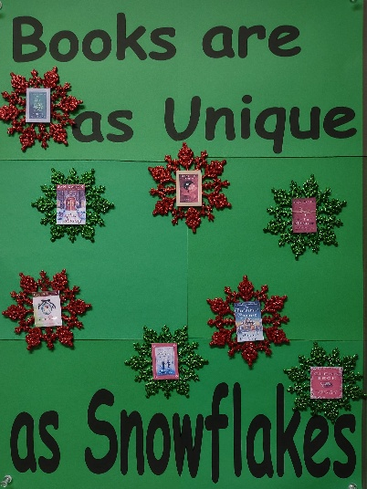**Musings from the Library!** Since we are feeling the chilly temperatures and the floating snowflakes, it is time to settle down in a warm comfy chair with an inviting book or two or three or more! This month we are highlighting our **GUIDEPOSTS BOOKS SERIES**. Louise MacIntosh has gifted us with this amazing and very popular series. We have three different series located on the top shelves to the left as you enter the church library. Each series contains 20 to 24 books, and they have been written by many different authors. It is amazing how the authors fit plots together.

**The Miracles of Mable Cove** chronicles the adventures of four very different women whose paths cross in a seaside town in Maine. Diane, Shelley, Margaret, and Beverly share many adventures and witness mysterious occurrences that connect them in unique ways. They also have something in common. Each is starting over in some way. Each has a second chance in life that gives them special opportunities to grow in faith, love, and grace.

**Tales from Grace Chapel Inn** is a series that focuses on Alice, Louise, and Jane, who turn their late father’s Victorian home into a bed and breakfast. They live in a charming and inviting town in Pennsylvania. The sisters all have different personalities, and at first, living and working together was not easy. Once they realize how to make the most of their strengths, they discover they make a fantastic team together. They meet such an array of guests throughout the books that humor must be one of their strongholds! The stories about faith and family are relaxing and fun. Just right for some good winter reading.

Our most recent fiction series, **Miracles and Mysteries of Mercy Hospital** is set in a Charleston, SC hospital that just overflows with Southern Charm. Our four principal employees are just as charming as their hometown. Evelyn, Joy, Anne, and Shirley all come from different walks in life, but they become friends as they work to solve the puzzling mysteries and witness the miracles happening at Mercy Hospital. They will exhaust you with their crazy ideas and off the chart humor.

**Big Hint:** It is time to start some colorful, warm winter reading with a cup of hot chocolate or a cup of tea! You will not believe what a great church library we have! Check it out! The library is open when the church is open. Come on in, relax, and read.

**UNITED WOMEN IN FAITH:** Out next circle meeting is: Wednesday: January 15, Noon in large conference room. Program is our Pledge Service – learning more about where our money goes. Bring a sandwich – beverage and dessert provided. ALL WOMEN OF THE CHURCH AND FRIENDS ARE INVITED TO OUR GATHERINGS ANYTIME

We continue to gather items for the Homeless in Chemung County. A box is under the United Women in Faith bulletin board by the kitchen door for your gift. We have filled the box three times in 2024. Candy Kirkwood has appreciated all of the items. We invite everyone in the church to add to the items for the Homeless. See the list on bulletin board. Thank you for helping God’s children who can use our gifts throughout the year.

*On Sunday, January 26, the women will lead the worship service. We include information on how and where we spend our money.*

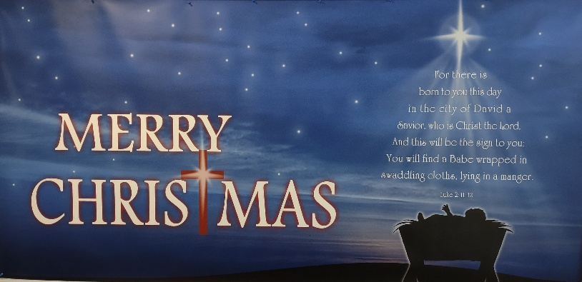

Have you seen this poster? We want to give a big

Thank You to Multi Media for this awesome donation. If you have not seen it, you can find it on the big bulletin board in the hallway near the Library Office?

**The Answer**

We are pleased to introduce a retired registered nurse, a modest individual who dedicates her time throughout the year to secure vendors for our Winter Fantasy Event. Let us extend our heartfelt gratitude to Barbara Burdette! Barb devotes her entire effort to ensure that vendors are eager to return each year. She invests countless hours in returning calls and emails, meticulously managing the spreadsheet to add or remove vendors. Additionally, Barb visits other craft shows to gather contact information from potential vendors interested in participating in our event. In the early stages, Barb, alongside Judi Driscoll, spent Thursday evenings on their hands and knees, using masking tape to outline the layout of the gym floor for the Boy Scouts and other helpers. Today, Barb expertly creates the schematics for table placements, accommodating the requests of each vendor, and she is thankful for the assistance of Boy Scout Troop 84, who help with the setup and takedown of the event. The financial contributions from the vendors, detailed below, reflect Barb's diligent efforts. Let us take a moment to acknowledge Barb's exceptional work and express our appreciation for her unwavering commitment to this significant event.

**Winter Fantasy 2024 Report**

**Departments...**

Chair Caners    $301.00

Cookbooks        $ 30.00 (We still have cookbooks available for $15. Find them in the church office)

Kitchen              $853.25

Sweet Shoppe $774.92

Church Ladies $887.00

**Department Total: $2846.17**

**Vendors** (59) at $35.00 would be $2065.00 (note: this should be a little higher with some spaces at $55.00)

Amounts for all parts of the event:

Winter Fantasy    $2846.17

Vendors               $2065.00

**Grand Total        $4911.17**

Proceeds will be distributed to the Kitchen Update fund and to the Trustee Maintenance Fund. When we close the kitchen update, the fund balance will be transferred to the Trustee Maintenance fund. (note: numbers are approximate based on data available at time written). Thank you all for your hard work. Bob Aiello

Kitchen Update News Coming Soon!

**Thank You!** We would like to express our gratitude to Bob Aiello, Larry Crandell, Barb Burdette, Boy Scout Troop 84, the individuals who assisted at the church craft table, those who managed the financial transactions, our very own angel, Pam Fluent, and our delightful elf, Connie Gillette. (Inquire about the number of years they have dedicated to this effort; you may be astonished by the answer!). Additionally, we extend our appreciation to all the cooks in our Holy Grounds Kitchen and the volunteers who contributed their time to set up and clean up. Last but not least, a special thanks to Santa Claus’s helper, Dennis Tubbs.

**Membership Committee**. We are updating our membership records and are trying to locate the following members of our congregation. Our current information isn’t correct. If you know any of these people and have their address or phone number would you please contact the church office (607-739-1943)? Sheila Brown, Donald & Sharon Beigun, Sandy & Christine Bussard, Amy D’Angelo, Sandra & William Felthousen, Dianna Kitzmann, Michael Leonard, Rebecca & David Romig, Elizabeth Vondercheck, MaryJane & David Walton and Diane & Eric Pratt, James McCann, and Dean Jackson. Thank you for your help.

**Stephen Ministry**: Currently we have 6 Stephen Ministers caring for 4 Care Receivers. After 50 hours of classes, we currently meet twice a month to continue education and discussion. We would like to start a new class and are looking for folks that have a willingness to be confidential listeners and supporters of people going through a rough time.

We are also looking for care receivers. It might be you! Are you just having a hard time right now with life? Do you need someone to just listen and allow you to work through your situation without judgement? If you are interested in learning more, please speak with Pastor Jeff McDowell, Jim Martin or Ande Tubbs.

**Karren’s Clothing Cupboard continues to grow in its outreach.** Participating in the Thorne Street summer free lunch program 2 times this past year we reached 35 families. We are in contact with a couple of individuals that work with the homeless on a regular basis that either bring them to us or take clothing to them. The number of families has increased this year, clothing for children is a constant need, as families struggle with finances. Currently we are running our coat giveaway in partnership with Outreach, we again ask that the coats are clean, working zippers, no holes or stains. In the colder weather, hooded sweatshirts, sweatpants and thermals have been a big thing.

Money put in the freewill offering box is used to purchase specific clothing for a family in need and put toward missions within the local church. We are currently in need of men’s winter coats in sizes 1x-4x, teen coats 12,14, 16, 18. Clothing can be brought to Karren’s Clothing Cupboard during regular hours. Tuesday 10-12 and Thursday 1-3. Please look at the clothing carefully, would you wear it? Is it ripped or stained? We do appreciate the donations; you have all been wonderful about supporting this mission.

Thank you

**Thank you to everyone who helped make some holiday cheer!**

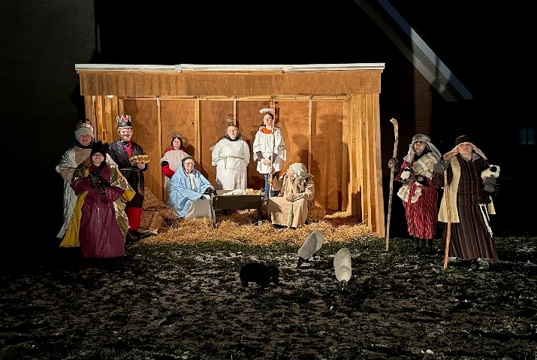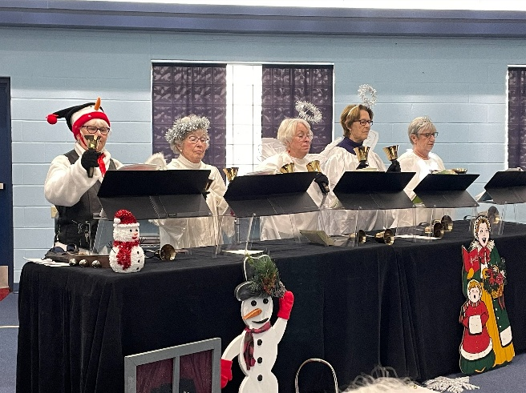

Living Nativity with the Scouts from Troop 84! Holy Harmony Angels with Bells!

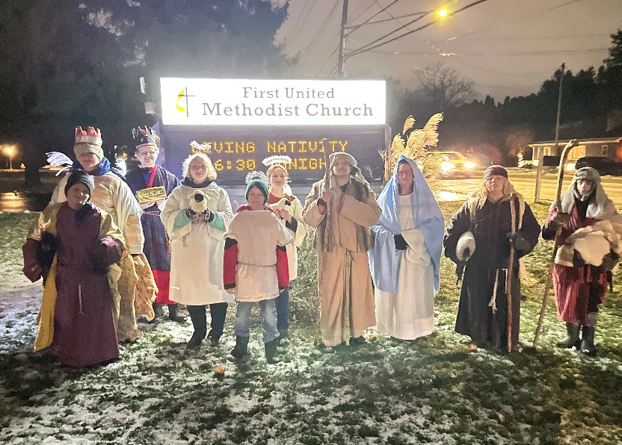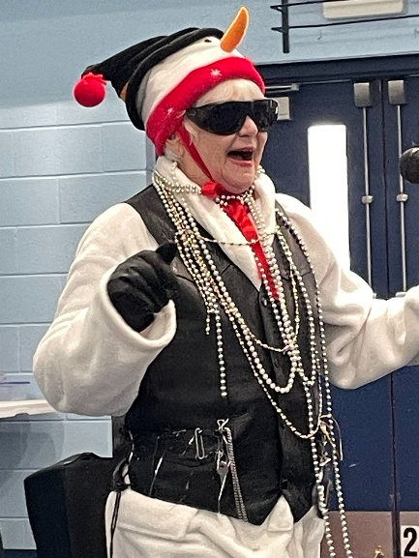

Shelby the Snow Broad