

Adult Sunday School in the LCR

Prayer Group each Monday, 10 am, WR

Women's ministry Bible Study each Wednesday at 11am, WR

Choir Practice each Saturday at 3pm

**Production Team** : Larry Crandell, Bob Aiello, Bob & Jamie Olcott

**Production Team email** : production@horseheadsumc.org

**Music Dire** **ctor:** David Peckham

**Liturgist:** Carrie Davidson

**Greeters** **:** Betty Drake; Mary Daniels

**Ushers:** Chad Miller; Bob Hauptman; Wayne Myers; Charlie Ellis

**Pastor:** Rev. Dr. Jeff McDowell

**Pastor’s Email:** pastorjeffmcd@yahoo.com

**Secretary:** Sandy Crane

**Church Phone:**  (607) 739-1943

**Web site:** www.hhdsumc.org

**Email:** office@horseheadsumc.org

See us live on Facebook & You Tube, Sundays at 9:30am

Check us out anytime on our Web site, You Tube or Facebook

Facebook: Horseheads United Methodist Church

You Tube: Hh 1st United Methodist Church

**Sermon Theme:**

Just as Jesus predicted his death, he prepared his disciples to face the future by promising the Holy Spirit. He called this spirit an unusual  word: paraclete, which has been translated in many ways. The simplest meaning is *divine helper.* Jesus promised that God would

send a *divine helper who comes alongside us will* be with us so we can

survive the challenge of living as Christians in a troubled world.

Another meaning of paraclete is “*comforter*.” Some people believe

there are angels helping them be safe in life. Some people lean on

their friends and relatives for strength. But all of us who call on Christ as savior can get *comforting help* from the Holy Spirit of God.

If you feel alone, God reminds you that isn’t ever true. How open are you to letting God help you through the Holy Spirit?

***“Working Together with All to Connect to God’s Love”***

# First United Methodist Church of Horseheads

**Mother’s Day, 4th Sunday of Easter**

The 4-week Sermon Series will be on the Holy Spirit,  leading up to Pentecost June 8.

# May 11,2025

**Greetings and Announcements**

{as this service begins, please use the white prayer cards on the pew-back in front of you, if you want something read aloud from the pulpit. During our first hymn,

the Ushers will collect cards to be read aloud.

## **Prelude** : At the Cradle Edvard Grieg

### *Call to Worship

Leader: Shout for joy to the Lord, all the earth.

**People:**  **Worship the Lord with gladness; come before him with joyful songs.**

Leader: his; we are his people, the sheep of his pasture.  Know that the Lord is God. It is he who made us, and we are

**People:**  **Enter his gates with thanksgiving and his courts with praise; give thanks to him and praise his name.**

## **\*Hymn:**Happy the Home When God is There #445 UMH

### **Unison Prayer

Holy Spirit, we welcome You. Holy Spirit, we know that You are the

Counselor of Truth, our help in need, and the One who fills us with the +  Spirit of God. Holy Spirit, we pray this very day to come into greater communion with You. You so graciously work to intercede for us to the Father, but also to comfort us with Your peace that goes beyond all understanding. Holy Spirit, please come. Following the will and heart of

the Father is our greatest desire, for we know His plans are best for us and, in the end, glorify the kingdom. Holy Spirit, please lead us by Your wisdom, discernment, and kindness throughout our lives. Holy Spirit, we welcome You this very day. In the Name of Christ Jesus, Amen.

**Joys and Concerns**  **Silent Prayer** **Pastoral Prayer**

**The Lord’s Prayer** (on screen) p.#895

### Gift of Music: Behold, How Good Michael Trotta

**Scripture**: **Proverbs 1:1-6** p.#584

Leader: The word of God for the people of God  *People: Thanks be to God!*

## **\*Hymn:** I Want a Principle Within#410 UMH

**Scripture: John 16: 7-12**  p.#110

Leader: The word of God for the people of God  *People: Thanks be to God!*

**Sermon**: **To Never Be Alone**

**Offering**

**Offering Music:** Flute Solo Thomas Arne

## **\*Hymn:** Spirit of God, Descend upon My Heart #500 FWS

**\*Benediction**

**\*Benediction Response:**

### Postlude: March in F Major Alexandre Guilmant

(Please feel free to be seated and enjoy the Postlude)

*indicates please stand, if able

UMH = red hymnal FWS = black songbook

**Announcements May 11, 2025**  **Karren’s Clothing Cupboard sign-up sheet for May and June is in the**  **entrance**. We are currently not taking clothing at this time.

Welcome to Worship today! If you are visiting today with us, please stop by

the visitor’s table , just outside the sanctuary. There is a gift bag there for **Schedule** you! Each Monday: Prayer group at 10:00. All are welcome to join.

May 12th: Funeral for Jose Knapp. Calling hours are 12-1pm.

Sunday School : 10:45am, Sr. High-Class Rm 18, Adult Sunday School in the Service is at 1pm in the chapel.

LCR  May 13th: Trustee meeting in Rm. 11, 7pm.  May 17th: Flower Sale Pick Up Day. 8am to 10:30am, FH.

***Flowers on the altar are given to the Glory of God and in***  ***memory of my***

***parents from Judi Driscoll***

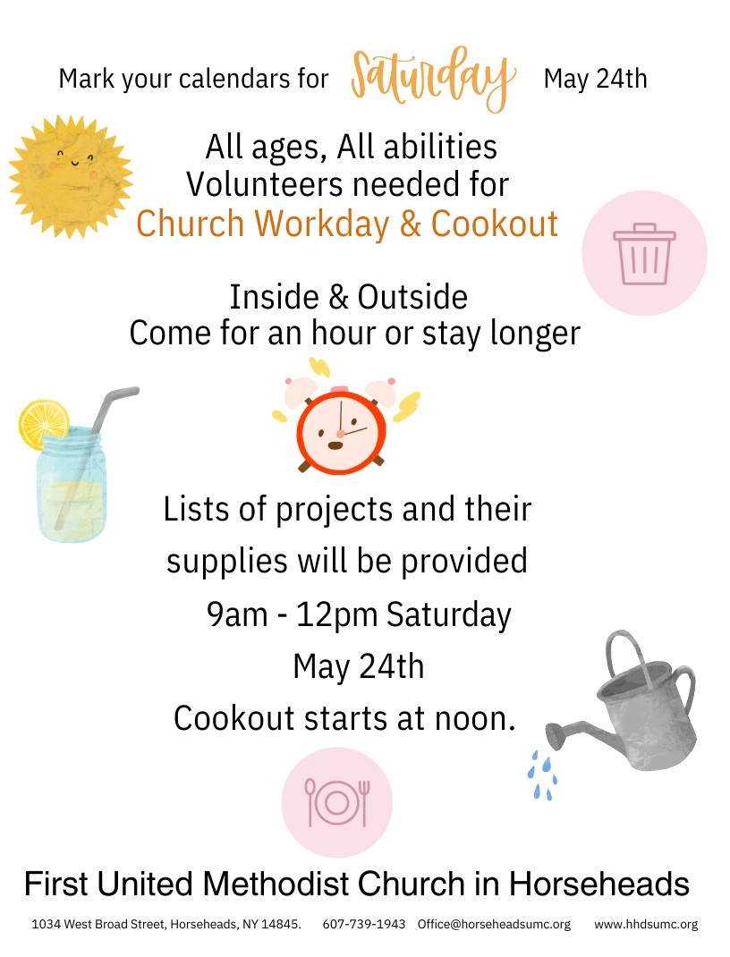

***Flowers on the altar are given to the Glory of God and in celebrating the love***

***and grace of*** ***Mothers.***

**Lawn Mowers:** The grass is growing and in need of mowing here at the

church. If you are interested in volunteering to help, please contact Gordon

Gillette at 607-562-3328. He will orient you to the work!

**th!**

**June newsletter deadline is May 15**

**Youth Gathering** - We had 3 youth show up for tying a blanket for homeless,

ping pong and learning to decorate cupcakes. There are several dates

i available to earn service time. Help unload flower truck May 16th -5:15pm; Help distribute flowers May17th - 9am; Church Work bee- May 24th 9-12.

**June Youth Gathering** 7th? 14th? 28th? Activity to be announced.

Remember, friends are always welcome. Any questions please call Ande

Tubbs at 607-739-7082

**Spring** **Cleaning**: Hammering out the list of chores we need to tackle sometimes moves at a snail’s pace. That is why Trustees are asking for  your HELP. As the old saying goes, “Many hands RAKE light work.” So please

sign up for our CHURCH WORKDAY May 24th from 9-12. Cookout to follow!

**Dear Lenten Friends, old and new,** Thank you very much for attending our

Soup and Bread supper on April 9th at Our Savior’s Lutheran Church in

Horseheads. Your very generous donations totaled $250.00 for the

Horseheads Food Pantry! Thank you again, Your friends at OSLC