Production Team: Larry Crandell, Bob Aiello, Bob & Jamie Olcott
Production Team email: production@horseheadsumc.org
Music Director: David Peckham
Liturgist: Maureen Nicolo
Greeters: Steve McIntosh
Ushers: Terry Bolt; Bob Hauptman; Dennis Tubbs; Phil Beard
Pastor: Rev. Dr. Jeff McDowell
Pastor’s Email: pastorjeffmcd@yahoo.com
Secretary: Sandy Crane
Church Phone: (607) 739-1943
Web site: www.hhdsumc.org
Email: office@horseheadsumc.org

See us live on Facebook & You Tube, Sundays at 9:30am

Check us out anytime on our Web site, You Tube or Facebook
Facebook: Horseheads United Methodist Church
You Tube: Hh 1st United Methodist Church

Sermon Theme:
When we really encounter God, we change more into the image of God. What do you think God looks like? What does it look like when someone has been in the presence of God? These questions might sound a little crazy if you ask them out loud, but today’s readings pull us to try to understand what we call the transfiguration of Jesus. The Bible says Jesus went up to a mountain, and “his face changed, and his clothes shone bright as a flash of lightning!” I think his true self showed through his normal face, and that was God inside him. What happens to your face when you feel loved, accepted and given a chair at God’s table? Do you smile? Others might notice your glow. It’s not a halo because you are not an angel! It is God on the inside of you, showing how much you are loved. When God comes to you, all you need to do it let Him in. You will be glowing with love and light.

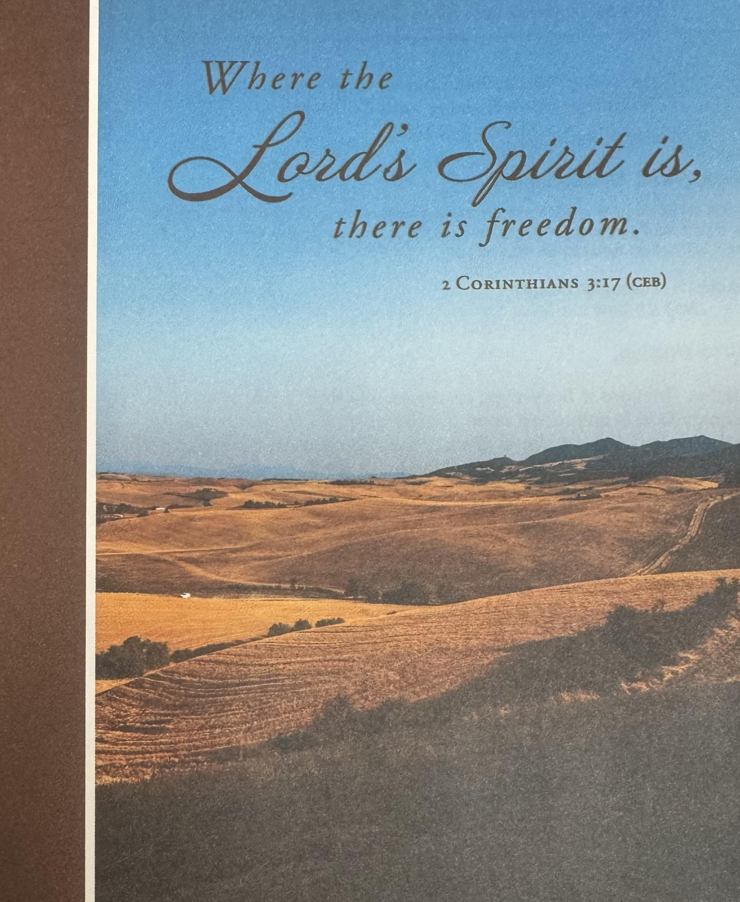

Joys and Concerns
Silent Prayer

Pastoral Prayer
The Lord’s Prayer (on screen) p.#895

Gift of Music:: Let Us Break Bread Together arr. Mark Milosevich
Scripture: Exodus 34:29-35 p.# 81
Leader: The word of God for the people of God
People: Thanks be to God!

*Hymn: Holy Ground #2272 FWS

Scripture: Luke 9:28-36 p.# 69-70

Leader: The word of God for the people of God
People: Thanks be to God!

Sermon: You are Absolutely Glowing!

Communion: We offer an Open Table to all who are willing to be open to Christ!
Offering will be received in the plate, as you come forward for communion.

Communion Music:

*Hymn: The Gift of Love #408 UMH
*Benediction
Postlude: Prelude and Fughetta John Stainer

[Please feel free to be seated and enjoy the Postlude}

*indicates please stand, if able UMH = red hymnal
FWS = black songbook

“ Working Together with All to Connect to God’s Love”

“Working Together with All to Connect to God’s Love.”

First United Methodist Church of Horseheads
Transfiguration Sunday with Communion
March 2, 2025

Greetings and Announcements

{as this service begins, please use the white prayer cards on the pew-back in front of
you, if you want something read aloud from the pulpit. During our first hymn, the
Ushers will collect cards to be read aloud.

Prelude: Song of Peace Jean Langlais
*Call to Worship
Leader: The Lord is Sovereign; let the people tremble in awe.
People: God is enthroned upon the cherubim; let the earth shake.
Leader: The Lord is great in Zion, and is high above all peoples.
People: Proclaim the greatness of the Lord our God,
and worship Yahweh upon the holy mountain.

*Hymn: When Morning Gilds the Skies #185 UMH

*Unison Prayer:
God of Glory and mercy,
before his death in shame your Son went to the mountain top,
and you revealed his life in glory.
Where prophets witnessed to him, you proclaimed him your Son,
but he returned to die among us.
Help us face evil with courage,
knowing that all things, even death,
are subject to your transforming power.
We ask this through Christ our Lord, Amen.

Announcements March 2, 2025
Welcome to Worship today! If you are visiting today with us, please stop by the visitor’s table just outside the sanctuary. There is a gift bag there for you!

Flowers on the altar are given to the Glory of God and in memory of Lesley Barfoot

February Church Committee/Event Schedule

Sunday School: 10:45am, Grades k-8 Fellowship Hall, Sr. High-Class Rm 18,
Adult Sunday School, Large Conference Room

Prayer Group each Monday, 10 am, WR

Women's ministry Bible Study each Wednesday at 10am, WR

Choir Practice each Saturday at 3pm

March 1st 4pm, Cantata Singers Concert, Sanctuary
March 3rd 7pm, Open Meeting for Hospitality Ministry, WR
March 5th 5pm, Faith Builders, SCR
7pm, ASH WEDNESDAY SERVICE, Chapel
March 6th 6:30pm, Outreach Committee, LCR
March 8th 4pm, Youth Gathering, FH
March 11th 7pm, Trustee Committee, Rm. 11
March 12th 5:30pm, Lenten Dinner, FUMC, FH
March 16th Rev. Ann Canfield
March 17th 9am, Quilt Ministry, FH
12pm, Open meeting for Ministry with Seniors, WR
7pm, Open meeting for Ministry with Seniors, WR
March 18th 1pm, Worship Committee, SCR
March 19th 12pm, United Women in Faith, LCR
5:30pm, Lenten Dinner, Oakwood United Methodist Church
7pm, Staff Parish, LCR (Note time change due to Lenten dinner)
March 22nd 4-6pm, Border Buddies Spaghetti Dinner, FH
March 25th 7pm, Stewardship, Rm. 11
March 26th Lenten Dinner, New Beginnings Church)
7pm, Church Council, LCR (Note time change due to Lenten dinner)

March 30th Soup to Go, K (Split Pea and Vegetable)

(WR: Wesley Room, K: Kitchen, FH: Fellowship Hall, S: Sanctuary, C: Chapel
LCR: Large Conf. Room, SCR: Small Conf. Room)

Youth Gathering: On Saturday, March 8th from 4-7pm in the Fellowship Hall. Please contact Ande Tubbs at 607-739-7082 as soon as possible if you can attend. Bring a friend.

Food Pantry Cart Location: If you are donating food to the food pantry, please find the grocery cart in front of the Outreach Committee bulletin board (side by the water fountain).

Women of Faith Homeless Collection: Please do not put food in the cart that you wish to donate to the food pantry. The UWF box for the homeless is under their bulletin board (by the kitchen door).

Community Events: Please see any community events on the Event Bulletin Board by the water fountain.

Altar Flower Sign up Calendar and monthly calendar: Please find these on the bulletin board on the kitchen door side.

New Membership Class: If you would like to join the church, please contact the church office this week and let us know. Classes be held Sundays after church on March 9, 16, 23, 30 from 10:45 – 11:45 a.m.

Karren’s Clothing Cupboard: Volunteer sign-up sheet for March is in the entranceway.

Lenten Suppers: Please join us each Wednesday from 5:30-6:30 for a light meal and a presentation based on the book, The God We Can Know, by Rob Fuquay. Below are the dates, places and speakers.
March 12th First UMC, 1034 W. Broad St., Horseheads Speaker: Rev. Susan Husted (retired)
March 19th Elmira Heights UMC, 212 Oakwood Ave., Elmira Heights Speaker: Rev. Pat Hubman (New Beginnings)
March 26th New Beginnings UMC, 300 Miller St., Elmira Speaker: Rev. Holly Strickland (Webb Mills UMC)
April 2nd Webb Mills UMC, 1623 Pennsylvania Ave., Pine City Speaker: Pete O’Neill (Oakwood UMC)
April 9th Our Savior’s Lutheran, 2872 Westinghouse Rd., Horseheads Speaker: Rev. Dr. Jeff McDowell (First UMC in Horseheads)

