**Pastor:** Rev. Dr. Jeff McDowell

**Pastor’s Email:** [pastorjeffmcd@yahoo.com](mailto:pastorjeffmcd@yahoo.com)

**Music Director:**  David Peckham

**Liturgist:** Kristin Griffiths

**Greeters:** Rita and Joe Colvin

**Ushers:** Guerry & Alberta Howard; Chad & Jennifer Miller

**Secretary:** Sandy Crane

**Church Phone:** (607) 739-1943

**Email:** [office@horseheadsumc.org](mailto:office@horseheadsumc.org)

**Production Team**: Larry Crandell, Bob Aiello, Bob & Jamie Olcott

**Production Team e-mail:** production@horseheadsumc.org

**Check us out on our Web site, Sundays at 9:30am**

*Facebook: Horseheads United Methodist Church

*You Tube: Hh 1st United Methodist Church

**Sermon Theme:**

I hope you have found your song. I hope you have been encountered by the God of the universe and found that for which you were created; to sing a song of thanks and blessings to the God who made you. This is a song which comes up from the depths of who you are, flavored by the experiences you have had, and overflows to the world and people around you to the glory of God. It is a sound you cannot contain, keep in, squelch, repress, or withhold. It is a song you need not explain, outline, promote, or convince others of. It simply is one you sing, without reservation. It comes when you know that God is singing a song over you and the words are that God loves you, that things are going to get better when you trust Him and that He will triumph over evil. Once you hear God’s song, just sing!

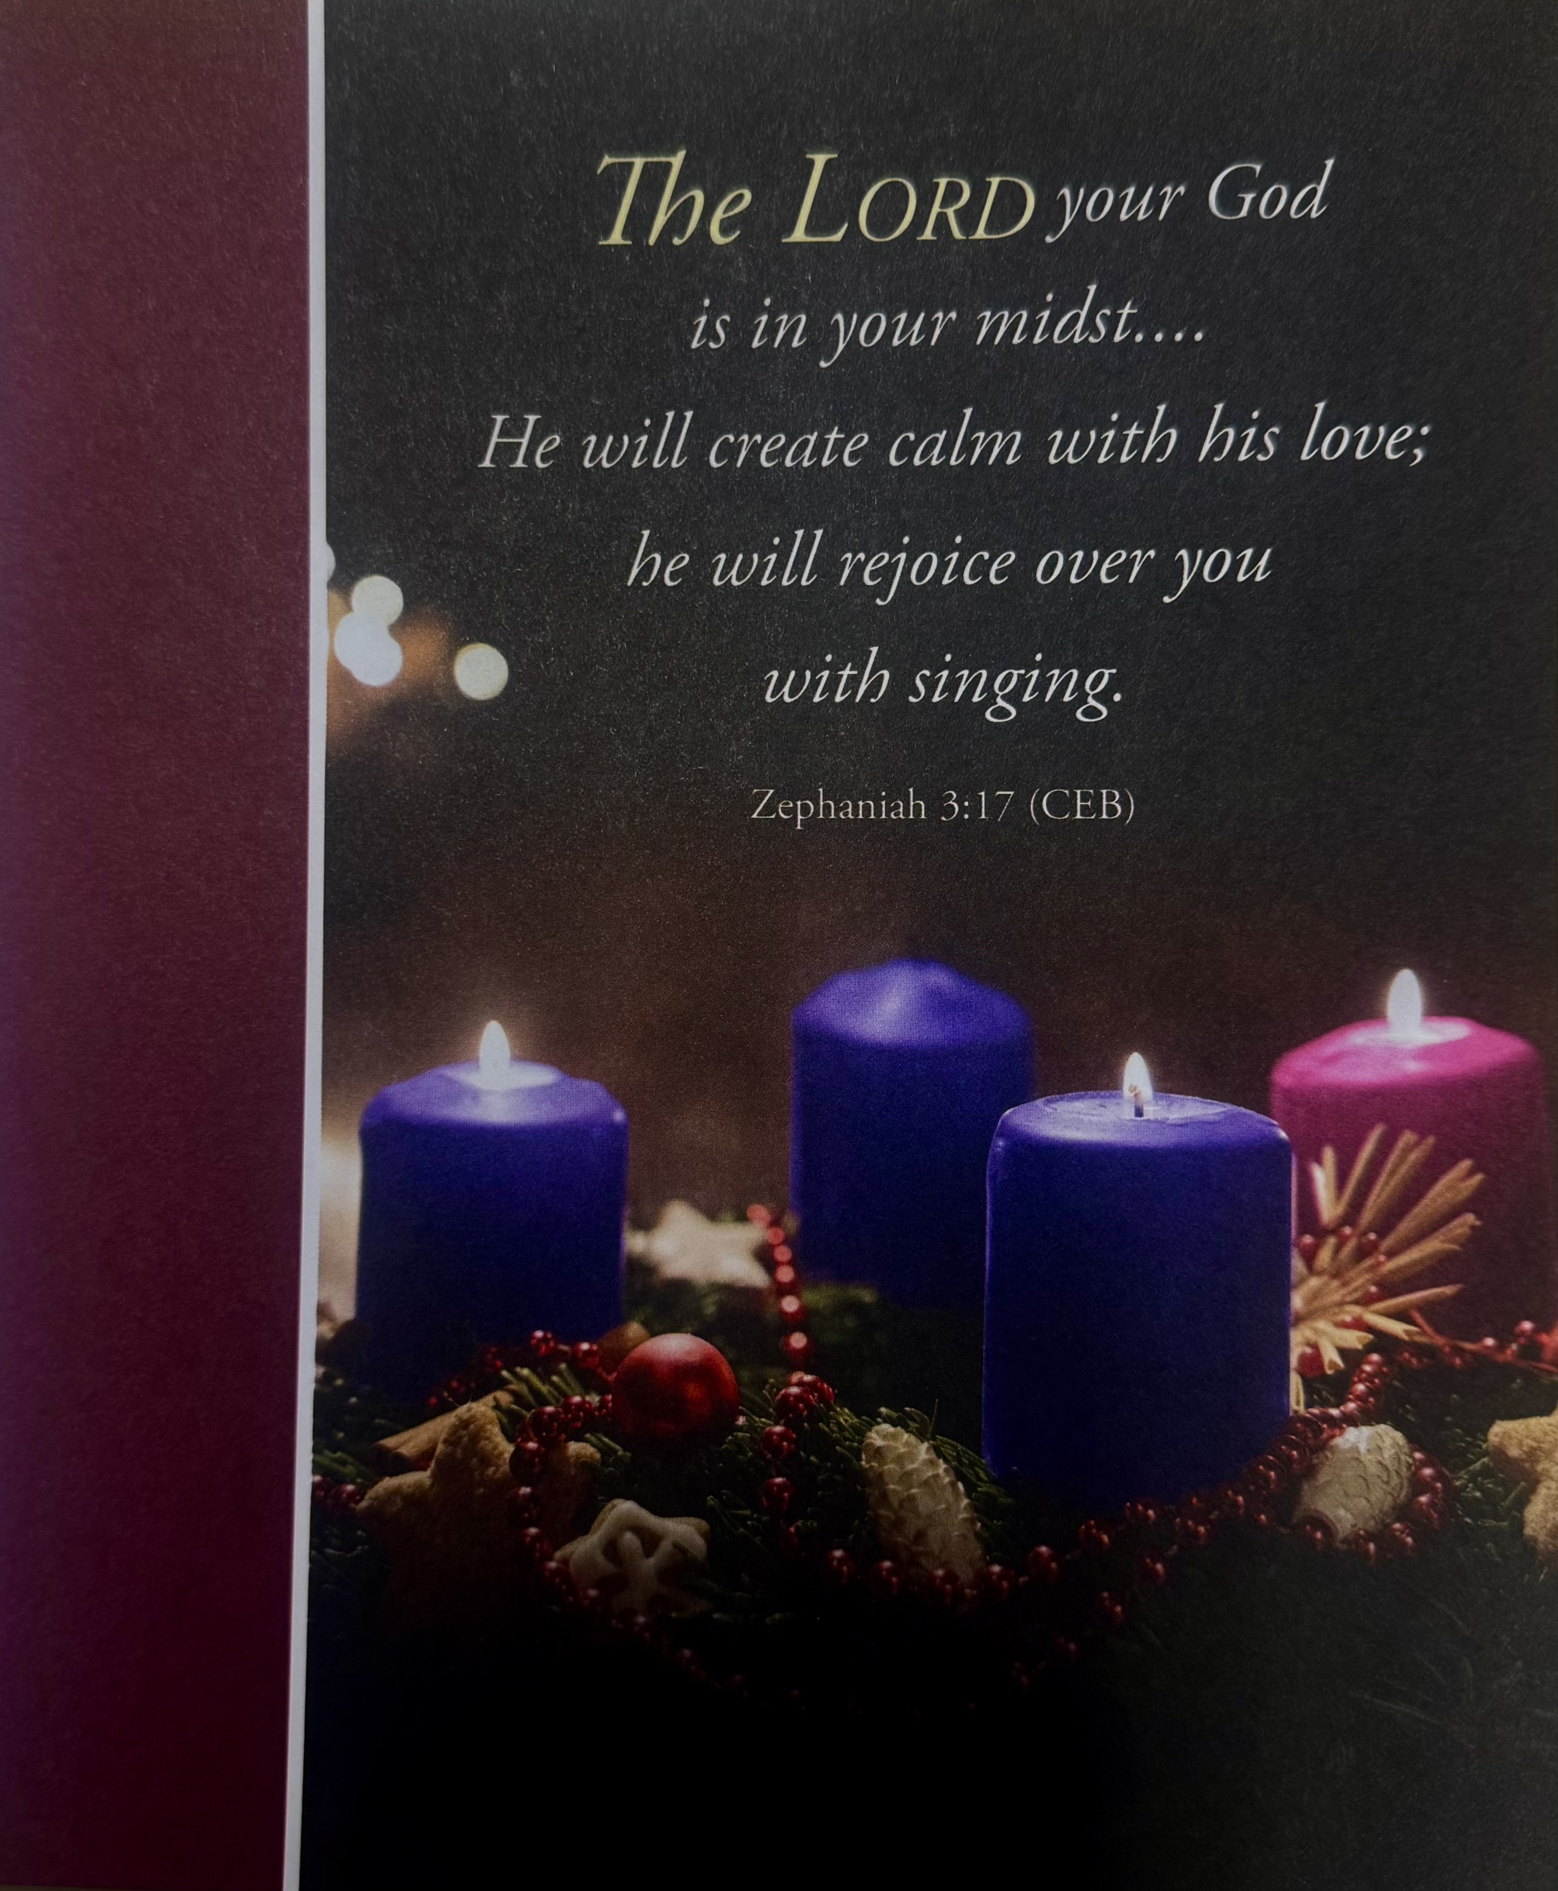



***“ Working Together with All to Connect to God’s Love”***

**First United Methodist Church of Horseheads**

**December 15, 2024**

**Third Sunday of Advent, Year C**

**Greeting and Announcements**

{as this service begins, please use the white prayer cards on the pew-back in front of you if you want something read aloud from the pulpit. During our first hymn, the Ushers will collect cards to be read aloud.}

**Prelude**: Lo, How a Rose E’er Blooming            arr. John Carter

**\* Lighting of the Advent Wreath Candles** Sarah Woodard & Addy

**\*Hymn:**  Hail to the Lord’s Anointed #203 UMH

**Unison Prayer:**

**Joys and Concerns** Chad Miller

**Silent Prayer**

**Pastoral Prayer**

**The Lord’s Prayer (on screen)** p.#895

**Gift of Music:** Kumbaya                                  arr. Paul Sjolund

**Young Disciples Time**

**Reader One:** No matter what troubles overwhelm us today, Isaiah reminds us that in all of our preparation and passionate pursuit of God’s coming kingdom, we must not forget that God’s salvation has come and is coming. “With joy you will draw water from the wells of salvation.” (Isaiah 12:3). With joy you will remember that God’s salvation is already present among us.

**Congregation: Faced with the troubles and the suffering of the world, we choose to live in joyful presence to God and one another. We will not turn away from the pain and the hurt in our world, and we will not stop rejoicing in God, whose salvation fills us to overflowing that God’s love might flow through us and flood our troubled world with** **hope, peace, and joy.**

**Reader Two:** We light this candle of joy as a sign of our commitment to be present to ourselves, our friends, our families, and our neighbors that in sharing our vulnerable lives we might share in the glorious joy of God’s salvation together.

Light the third (pink/rose) candle of the Advent wreath.

Creator of the universe, we stand amazed at your power and glory. We are eager to worship you and offer our praise, but we are often reluctant to answer when we hear you calling our name. We sing our songs of tribute in the sanctuary, but shy away from the river, lest we be baptized with the fire of the Holy Spirit. Forgive us when we forget your promise to be with us always, O God. Renew us with the power of your ever-present love and strengthen us to proclaim your justice throughout the world. Amen

**Joys and Concerns**

**Silent Prayer**

**Pastoral Prayer**

**The Lord’s Prayer (on screen)** p.#895

**Gift of Music:** O Come, O Come Emmanuel          Timothy Kile

**Young Disciples Time**

**Scripture: Isaiah 12:1-6**  p.#641

Leader: The word of God for the people of God

*People: Thanks be to God!*

**\*Hymn:** Come, Thou Long Expected Jesus #196 UMH

**Scripture: Zephaniah 3:14-20** p#877

Leader: The word of God for the people of God

*People: Thanks be to God!*

**Sermon:** Hearing the Lord’s Song

**Offering**

**Offertory Music:** Wachet auf!                                              J.S. Bach

**Doxology**

**\*Hymn:** Good Christian Friends, Rejoice #224 UMH

**Benediction**

**Postlude:** The Light is Coming  Dave Brubeck

from The Light in the Wilderness

[Please feel free to be seated and enjoy the Postlude]

*indicates please stand, if able

UMH = red hymnal FWS =   black songbook

Announcements Dec 15, 2024

*Flowers on the altar are given to the Glory of God and in celebration*

*of our 40th Wedding anniversary, Jeff and Barb McDowell and in loving memory of Robert Joralemon from Sharron Joralemon*

Welcome to Worship today! If you are visiting today with us, please stop by the visitor’s table just outside the sanctuary. There is a gift bag there for you!

**Sunday, Dec. 15th:**

**10:45am**, Sunday School: Grades k-8 Fellowship Hall, Sr. High-Class Rm 18, Parent Class-Rm 21, *Adult Sunday School*, Large Conference Room, *Choir Practice* each Saturday at 3pm, CR

**Monday, Dec. 16th:**

**9:00am**, Quilting, FH

**Tuesday, Dec. 17th:**

**5:45pm**, Crystal Chords Christmas Concert, Sanctuary

**Wednesday, Dec. 18**

**12:00pm**, Women’s Christmas Luncheon in the Fellowship Hall

**2:00pm**, Missions Committee, LCR

**5:30pm**, Stephen Ministry, Rm. 12

**7:00pm**, Church Council, Rm. 11

**Saturday, Dec. 21**,

**6:00pm**, Longest Night Service in Chapel

**Sunday, Dec. 22,**

Soup to Go, Kitchen

**10:45am**, Candlelighter’s Rehearsal (Teens), Sanctuary

Christmas Eve Candlelight Worship Tuesday, **December 24 at 7:00pm**

**Your Input is Needed!** Members of our Church Council are working on the Six Areas of Church Growth stemming from the Ministry Audit. Changes are being made in the New Year to help us be more effective and efficient.

**Living Nativity.** You can find the sign-up sheet in the entranceway.

Living Nativity dates and times. Wed Dec. 18-Mon Dec 23, 4-8pm,

Tuesday Dec 24 10-8pm.

.

         

**Stewardship.**  There are a number of different giving opportunities in December.  To ensure your gift is applied correctly, please indicate the following on your check or envelope:

**Staff Gift**   Monetary gift to our staff recognizing their 2024 efforts and accomplishments.

**Christmas - Giving**   Outreach Christmas Giving Tree.

**Christmas - Church**   Christmas gift to support church operations.

**Christmas - LEF**   Christmas gift to our Living Endowment Fund.

**Living Endowment Fund:** These funds are generally given in honor or in memory of individual(s).  This fund, set up years ago, is managed by our Investment Committee. All gifts are kept in this fund (principal), and investment income on this principal is used to help fund operations.  Each Advent Season we offer you the opportunity to donate in honor or in memory of someone. Please fill out the information below and return it to the church office. Please make checks out to the church with Living Endowment on the memo line.

Living Endowment Fund

**In Honor of:** (print name) __________________________________________

**In Memory of:** (print name)__________________________________________

**Amount enclosed:** $________

**Your Name**: __________________________________________________

Our church is blessed to have a devoted staff.  They give of their time and talents to ensure jobs well done.  Our staff consists of Pastor Jeff McDowell; Music Director, David Peckham; Secretary, Sandy Crane; Parish Visitor, Cindy Ellis; Superintendent of Buildings, Jamie Olcott; and Lullaby Room, Sarah Woodard.  Please put your donation in the collection plate. Your generosity is appreciated.

Your Staff Parish thanks you. Brent Arnold, Fred Daniels, John Young, Gordon Gillette, Ann Rouse, Jan Przybylski, Christina Peklak.

**Winter Coat Giveaway** Donate! Good to excellent condition, infants through adults, all sizes. no wool / dry clean only.

Take One! Coats are in the main lobby, chapel lobby, and West Wing.