**Pastor:** Rev. Dr. Jeff McDowell

**Pastor’s Email:** [pastorjeffmcd@yahoo.com](mailto:pastorjeffmcd@yahoo.com)

**Music Director:**  David Peckham

**Liturgist:** Barb McDowell

**Greeters:** Judi Driscoll

**Ushers:** Dick Williams; Terry Bolt; Chad Miller; Dennis Tubbs

**Secretary:** Sandy Crane

**Church Phone:** (607) 739-1943

**Email:** [office@horseheadsumc.org](mailto:office@horseheadsumc.org)

**Production Team**: Larry Crandell, Bob Aiello, Bob & Jamie Olcott

**Production Team e-mail:** production@horseheadsumc.org

**Check us out on our Web site, Sundays at 9:30am**

*Facebook: Horseheads United Methodist Church

*You Tube: Hh 1st United Methodist Church

**Sermon Theme:**

No matter what is going on around us and the bleak picture of our daily world news, God is not giving up on us and God will make it all right in the end. We must not give up hope, even if we face danger, illness or death. God’s promise came true in Jesus first and foremost as Savior of all the world. We are simply in a waiting time for God’s timing to fully fix our broken world. Do not despair, and do not give up your joyful living in this troubling world. Christ is alive and He will make all things right, in God’s time.

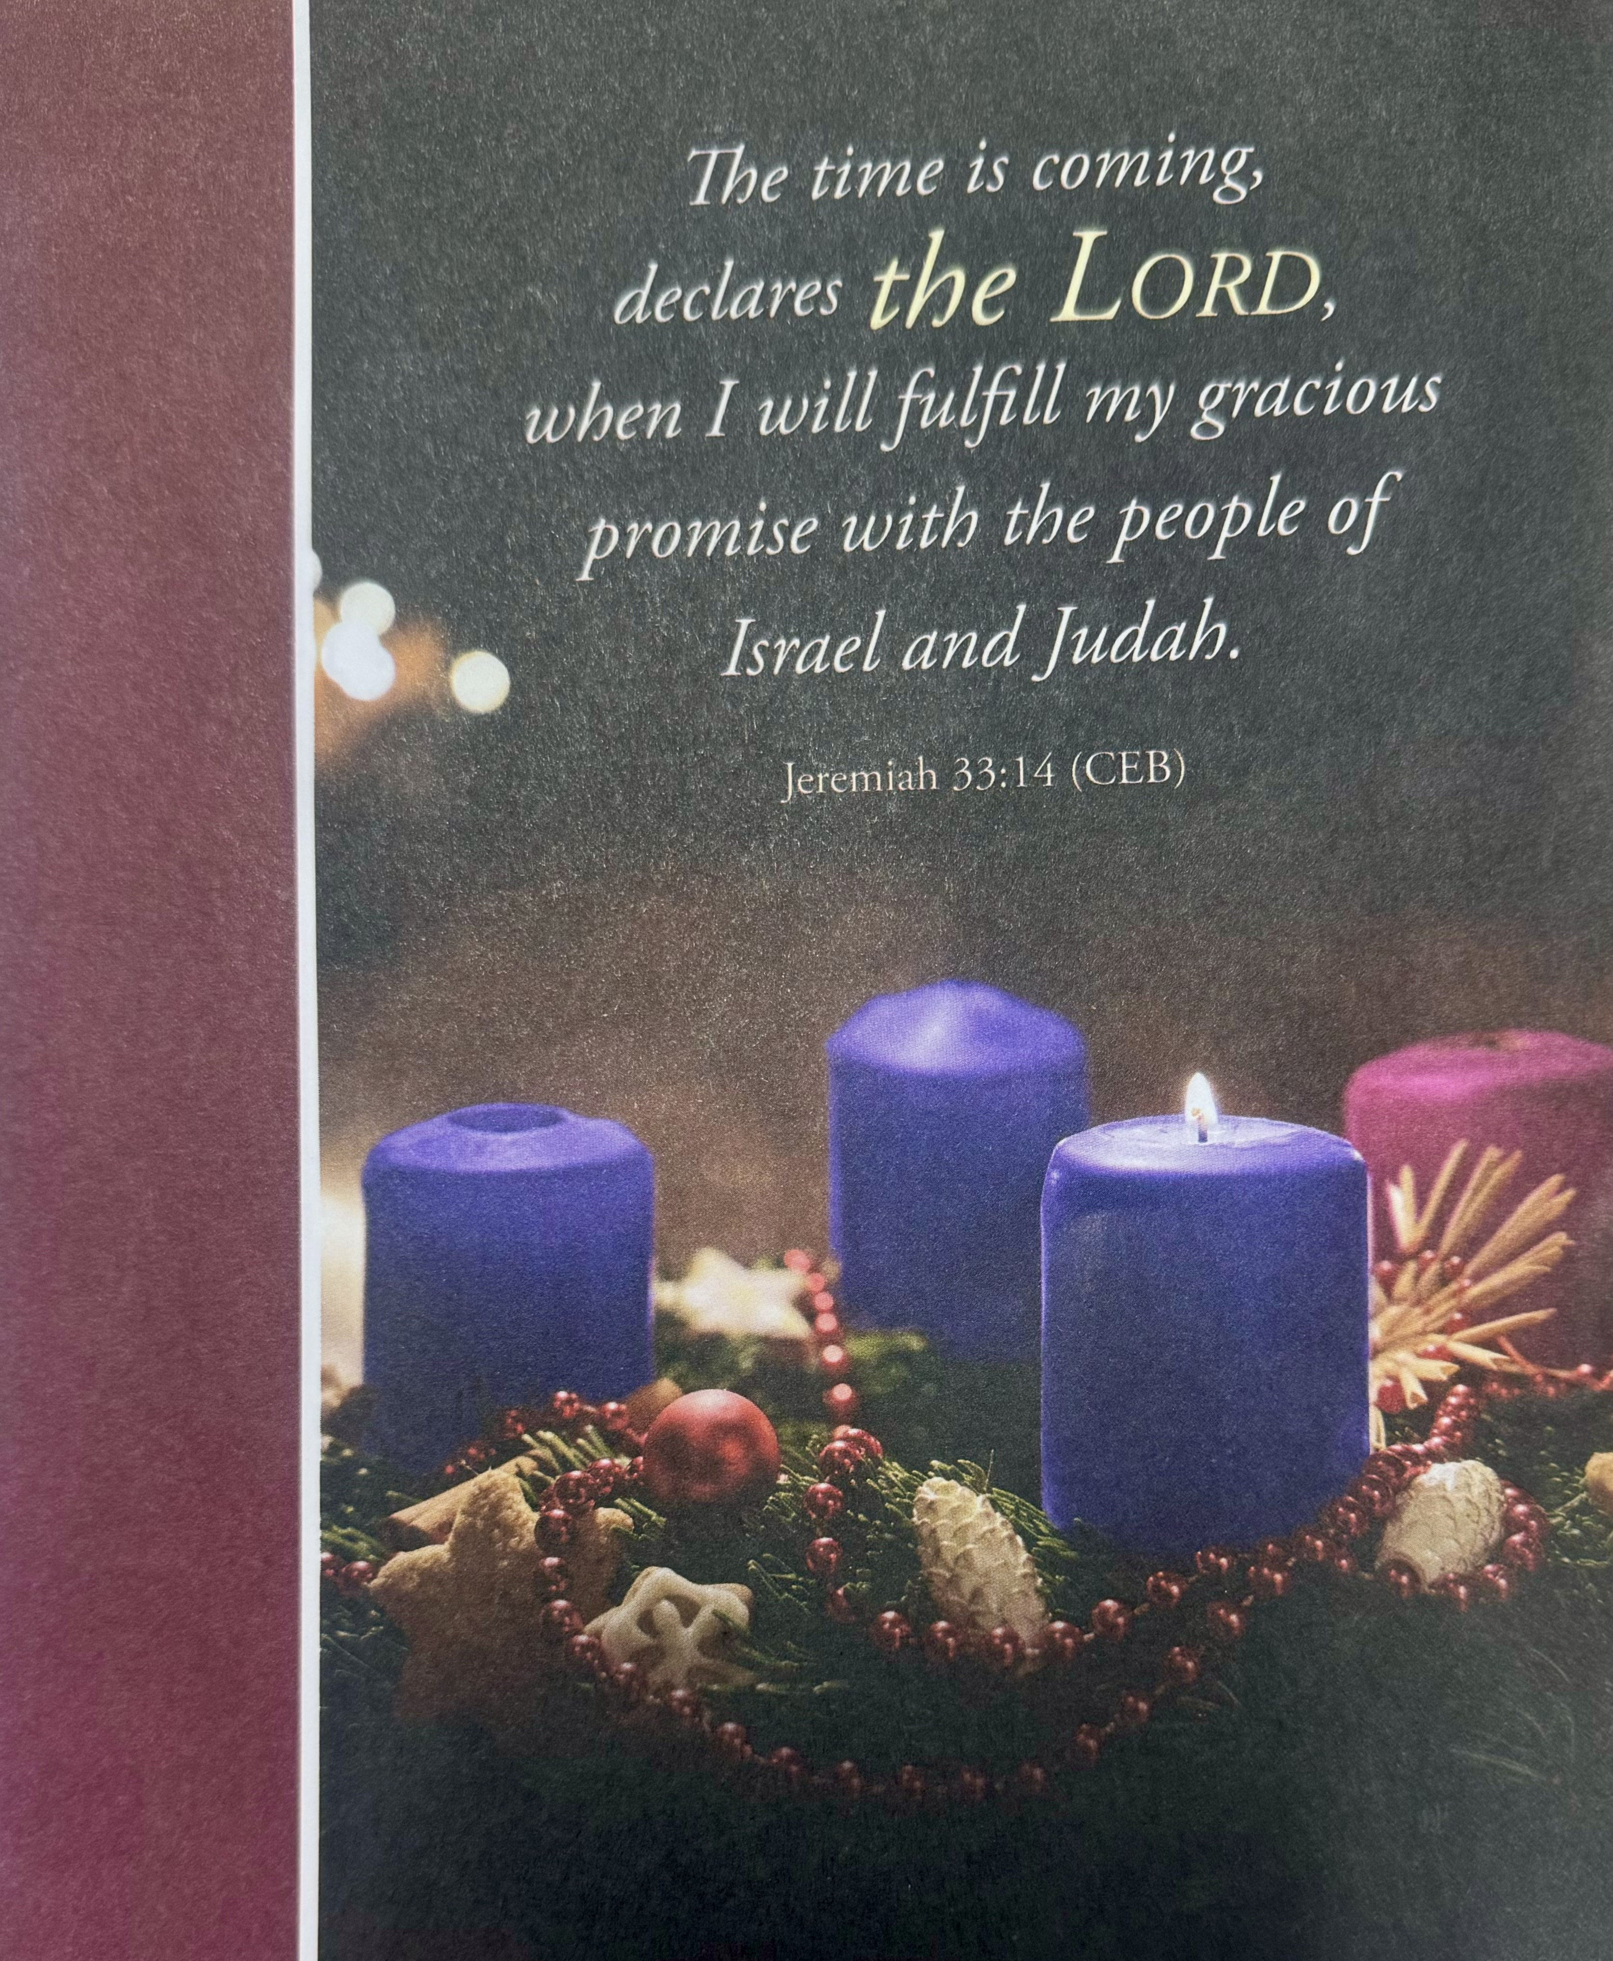



***“ Working Together with All to Connect to God’s Love”***

**First United Methodist Church of Horseheads**

**December 1, 2024**

**FIRST SUNDAY IN ADVENT**

**Greeting and Announcements**

{as this service begins, please use the white prayer cards on the pew-back in front of you if you want something read aloud from the pulpit. During our first hymn, the Ushers will collect cards to be read aloud.}

**Prelude**: O Come, O Come Emmanuel arr. Matt Hyzer

**Advent Introit Prepare Ye arr. Joe Crupi**

**\*Call to Worship**

**\*Hymn:** Come, Thou Long Expected Jesus #196 UMH

**Joys and Concerns** Chad Miller

**Silent Prayer**

**Pastoral Prayer**

**The Lord’s Prayer (on screen)** p.#895

**Gift of Music:** Kumbaya                                  arr. Paul Sjolund

**Young Disciples Time**

**Lighting of the Advent Wreath Candle**

**Reader One:** From deep in the past, Jeremiah calls to us, *“The days are surely coming, says the LORD, when I will fulfill the promise I made to the house of Israel and the house of Judah.”* (Jeremiah 33:14). Beloved, the days are surely coming when the yearning of the land; the longing of the sun, moon, and stars; the desperate need of the people of earth to flourish and find peace will receive their fulfillment.

**Congregation: While fear, anxiety, misinformation, and suspicion surround us on every side, we choose to watch and wait in hope, preparing our hearts to receive, and give back God’s grace already at work in our midst. Let God be glorified!**

**Reader Two:** We light this candle of hope as a sign of our commitment to pay attention and prepare for the days that are surely coming and are already here—the days when God’s kingdom of love, justice, and mercy will reign.

**Announcements Dec 1, 2024**

**First Week of Advent**

***Flowers on the altar are given to the Glory of God***

Welcome to Worship today! If you are visiting today with us, please stop by the visitor’s table just outside the sanctuary. There is a gift bag there for you!

**Sunday, Dec. 1st:**

**10:45am**, Sunday School: Grades k-8 Fellowship Hall, Jr. High-Class

Rm 18, Parent Class-Rm 21, Adult Sunday School, Large

Conference Room, Choir Practice each Saturday at 3pm, CR

**Wednesday, Dec. 4th:**

**5:30pm,** Stephen Ministry, Rm.12

Faith Builders will not be meeting

**Thursday, Dec. 5th:**

**6:30pm**, Outreach, LCR

**Sunday, Dec. 8th:**

**10:30am,** Karren’s Clothing Cupboard invites you to come see them after the service.

**Stewardship:** 2025 pledge cards will be mailed out this week. Please pray, pledge, and return the pledge card to the church by Sunday, January 5th. Thank you all for your strong support in 2024 and 2025.

**Living Nativity.** Our church family portrays the nativity scene outdoors on the front lawn during the days before Christmas. The time spent with friends and family in the Living Nativity is special. We also send a wonderful message to the community about the true meaning of Christmas. If you would like to participate in this event, please give Louise McIntosh (607-739-1954) a call or call the church office and we will schedule you. (607-739-1943). You can find the sign-up sheet in the entranceway. Living Nativity dates and times: Wed Dec. 18- Mon Dec 23, 4-8pm, Tuesday Dec 24 10- 8 pm. Shifts are preferably one hour but will entertain 30-minute shifts if necessary. Volunteers must report no later than 15 minutes before their shift starts. All costumes are provided, just wear something to keep warm. Dates to keep on your schedule for the Advent Season.

**Have you ever thought about going on a mission trip?** Sid Spencer is leading a mission trip to Honduras Jully 10 thru July 19. If you are interested, you can contact him at sspencer@stny.rr.com.

**Unison Prayer:**

God of our Expectation, we praise you for promised days when you will execute Shalom: love, peace, health, and well-being for the people who walked in darkness. We await the promised days when disease is cured, when every gun is beaten into tools for rebuilding, when every child can develop their gifts, and every adult sees children as a gift from God. We desire, O God of our Hope, promised days when no city fears hurricanes, no country fears bombs, and no tribe fears being killed by another. We thank you for the promised days when no person fears because God chose to create all people in God’s image. We thank you for our hope and for your promised days. Amen.

**Joys and Concerns**

**Silent Prayer**

**Pastoral Prayer**

**The Lord’s Prayer (on screen)** p.#895

**Gift of Music:** Our Hope is in Emmanuel Victor Johnson

**Scripture: Jeremiah 33:14-16**  p.#738

Leader: The word of God for the people of God

*People: Thanks be to God!*

**\*Hymn:** Time Now to Gather ` #2265 FWS

**Scripture: I Thessalonians 3:9-13** p#207

Leader: The word of God for the people of God

*People: Thanks be to God!*

**Sermon: Living with Incredible Hope**

**Communion:** We offer an Open Table to all who are willing to be open to Christ!

Our Offering will be received in the plate, as you come forward for communion.

**Offertory Music:**  

**\*Hymn:** Come Now, O Prince of Peace  #2232 FWS

**Benediction**

**Postlude:** To God We Render Thanks and Praise J.S. Bach

[Please feel free to be seated and enjoy the Postlude]

*indicates please stand, if able UMH = red hymnal FWS =   black songbook

**Announcements Dec 1, 2024**

**First Week of Advent**

***Flowers on the altar are given to the Glory of God***

Welcome to Worship today! If you are visiting today with us, please stop by the visitor’s table just outside the sanctuary. There is a gift bag there for you!

**Sunday, Dec. 1st:**

10:45am, Sunday School: Grades k-8 Fellowship Hall, Jr. High-Class Rm 18, Parent

Class-Rm 21, Adult Sunday School, Large Conference Room, Choir Practice each

**Saturday at 3pm, CR**

**Wednesday, Dec. 4th:**

5:30pm, Stephen Ministry, Rm.12

Faith Builders will not be meeting

**Thursday, Dec. 5th:**

6:30pm, Outreach, LCR

**Sunday, Dec. 8th:**

10:30am, Karren’s Clothing Cupboard invites you to come see them after the service.

**Stewardship:** 2025 pledge cards will be mailed out this week. Please pray, pledge, and return the pledge card to the church by Sunday, January 5th. Thank you all for your strong support in 2024 and 2025.

**Living Nativity.** Our church family portrays the nativity scene outdoors on the front lawn during the days before Christmas. The time spent with friends and family in the Living Nativity is special. We also send a wonderful message to the community about the true meaning of Christmas. If you would like to participate in this event, please give Louise McIntosh (607-739-1954) a call or call the church office and we will schedule you. (607-739-1943). You can find the

sign-up sheet in the entranceway.

**Living Nativity dates and times.** Wed Dec. 18- Mon Dec 23, 4-8pm, Tuesday Dec 24 10- 8 pm

Shifts are preferably 1 hour but will entertain 30 min shifts if necessary. Volunteers must report no later than 15 minutes before their shift starts. All costumes are provided, just wear something to keep warm.

         

**Dates to keep on your schedule for the Advent Season.**

Saturday, December 14 9:00 am – 12 pm Church Decorating Party

Wednesday, December 18 12:00 pm Women’s Christmas Luncheon

Saturday, December 21 6:00pm Longest Night Service in Chapel

Tuesday, December 24 7:00pm Christmas Eve Candlelight Worship

**Christmas Events/Concerts**

Winter Fantasy Craft Show, December 7th, 9am to 3pm

Lessons and Carols, December 8th at 5pm in our Sanctuary

Crystal Chords Christmas Concert, December 17th, 6:45-8:15pm in our Sanctuary

Be part of the Living Nativity

**Outreach:** It is hard to believe that Christmas will be here before we know it. Once again, Outreach is hoping to purchase gift cards for 8 families who need help to bring Christmas to their homes. Beginning today, Nov. 24, we will be asking for donations so that gift cards can be purchased in time for families to shop. If you are willing to help, please take an envelope from the small Christmas Tree and be a Christmas Angel. Cash or checks written to the church, (if writing a check, put Christmas Giving on the memo line) should go in one of the envelopes. The envelopes can be put in the mailbox by the tree, in the collection plates, or given to Sandy in the office. All donations need to be in by Dec.13.

**Winter Fantasy, December 7th, 2024**

**Winter Fantasy sign-up sheets are posted** in the entranceway for Set-Up, Clean-Up help and Kitchen help. Please sign up for any donations for the Holy Grounds Kitchen that you could help us with! We are still in need of kitchen helpers and donations of food items/drinks. For any food donations/kitchen help questions, call Janell Sullivan, 607-739-3797

**Please sign up** to help setting up tables/chairs on Thursday and cleaning up on Saturday. Any questions please contact Bob Aiello, 607-331-6121, Larry Crandell: 607-731-1816.

**Winter Fantasy Help Needed:** Our list of Vendors for Winter Fantasy has filled the building!! With more calls each day asking for space. Unfortunately, the committee had to turn away some, but all rooms are filled! So please come shop, even just to buy just a small ornament or a large lawn decoration, a homemade gift, and of course our own sweet shop has something you should not have but are going to buy anyway! And don’t forget, lunch made by our own Holy Grounds kitchen staff. On December 7th we are asking you, our congregation, to come over to help support the church and the vendors who make our fund raiser the successful event it has become for 22 years now! Please check the Facebook page and share the Winter Fantasy Poster on your own page.

**Church Winter Fantasy table:** We will be setting up the table on Friday, Dec. 6, starting at 9am. Please bring your items to donate to the church craft table that morning or if you can’t come then, there will be a bin in the workroom across from the church office to put items in. Please make sure you have your list and items priced. Thank you to

everyone participating in this.

**Please join us for the “HANGING OF THE GREENS.”** Saturday, Dec 14th @ 9 am we will be decorating the Sanctuary for the Christmas season. This includes the altar, the tree, and wreaths. We display evergreens because they never change color, reminding us of the everlasting life that isours through Jesus. The wreath is a never-ending circle, reminding us of God’s endless love. Donuts, coffee, and juice provided. BRING THE FAM!

**Lost and found:** A pair of dark sunglasses were left in the church office on 11/25. Please find them on the ledge by the office window.

**Our church is blessed to have a devoted staff.** They give of their time and talents to ensure jobs well done. Our staff consists of Pastor Jeff McDowell, Music Director, David Peckham, Secretary, Sandy Crane, Parish Visitor, Cindy Ellis, Superintendent of Buildings, Jamie Olcott, and Lullaby Room, Sarah Woodard. It has been a tradition at this time of year to give these people a monetary gift to say thank you. If you would like to make a donation for the staff Christmas Giving, please mark your donation as Christmas Giving and put it in the collection plate or turn it in to the office. Your generosity is appreciated. Your Staff Parish thanks you, Brent Arnold, Fred Daniels, John Young, Gordon Gillette, Ann Rouse, Jan Przybylski, Christina Peklak.

**Annual Coat Give Away:** Karren’s Clothing Cupboard along with Outreach continues our coat give away. If you have a coat you don’t need any more and it is in good to excellent condition (infants through adults-all sizes), we would love to help you find a new home for it. Please no wool or dry clean only. Coats are now located three different locations. If you need a coat, please take one. Find them in the narthex, near the chapel and across from Karren’s Clothing Cupboard. Thank you for all your support.

**Karren’s Clothing Cupboard** is still looking for good to excellent winter coats, preferably not wool and men’s jeans, pants sizes 29- 32 waist, children’s clothing in smaller sizes especially and larger sizes for men and women, 1x up. December 8th will be open after church for anyone wanting to check out our new set up. The sign-up sheet is in entranceway for the month of December.

**Living Endowment Fund:** Gifts designated to the Living Endowment go into our Living Endowment Fund. These funds are generally given in honor or in memory of individual(s). This fund, set up years ago, is managed by our Investment Committee. All gifts are kept in this fund (principal), and investment income on this principal is used to help fund operations. Each Advent Season we offer you the opportunity to donate to the Living Endowment Fund in honor or in memory of someone. Please fill out the information below and return it to the church office. Please make checks out to the

church with Living Endowment on the memo line.

**Living Endowment Fund**

**In Honor of:**

(Print name)______________________________________________________________

**In Memory of:**

(Print name)______________________________________________________________

Amount enclosed: $________ Your Name: _____________________________________