**Pastor:** Rev. Dr. Jeff McDowell

**Pastor’s Email:** [pastorjeffmcd@yahoo.com](mailto:pastorjeffmcd@yahoo.com)

**Music Director:**  David Peckham

**Liturgist:** Judi Driscoll

**Greeters:** Dick and Linda Williams

**Ushers:** Dick Williams; Terry Bolt; Chad Miller; Dennis Tubbs

**Secretary:** Sandy Crane

**Church Phone:** (607) 739-1943

**Email:** [office@horseheadsumc.org](mailto:office@horseheadsumc.org)

**Production Team**: Larry Crandell, Bob Aiello, Bob & Jamie Olcott

**Production Team e-mail:** production@horseheadsumc.org

**Check us out on our Web site, Sundays at 9:30am**

*Facebook: Horseheads United Methodist Church

*You Tube: Hh 1st United Methodist Church

**Sermon Theme:**

This life is all about love: the love of God, living in us and bubbling up back to God and other people. This is spelled out in the Old Covenant God made with us; we were commanded to love the Lord with all our being. Of course, we all have fallen short of that. Can any one of us say we live in that reality every moment, all our lives? But in Jesus, God made a way for love to grow from the inside out, by putting love there in the first place. Today we remember people close to us whom we have lost to death. But what we tend to remember best is the moments of love shared between us. This love (and any human love) comes from God through Jesus Christ, and nothing can take that away. We love, because He first loved us. This is the mystery of faith. So, take heart, you who have lost someone you love. If they shared love with you, it was God’s love. That was written on their hearts by Jesus the Savior.



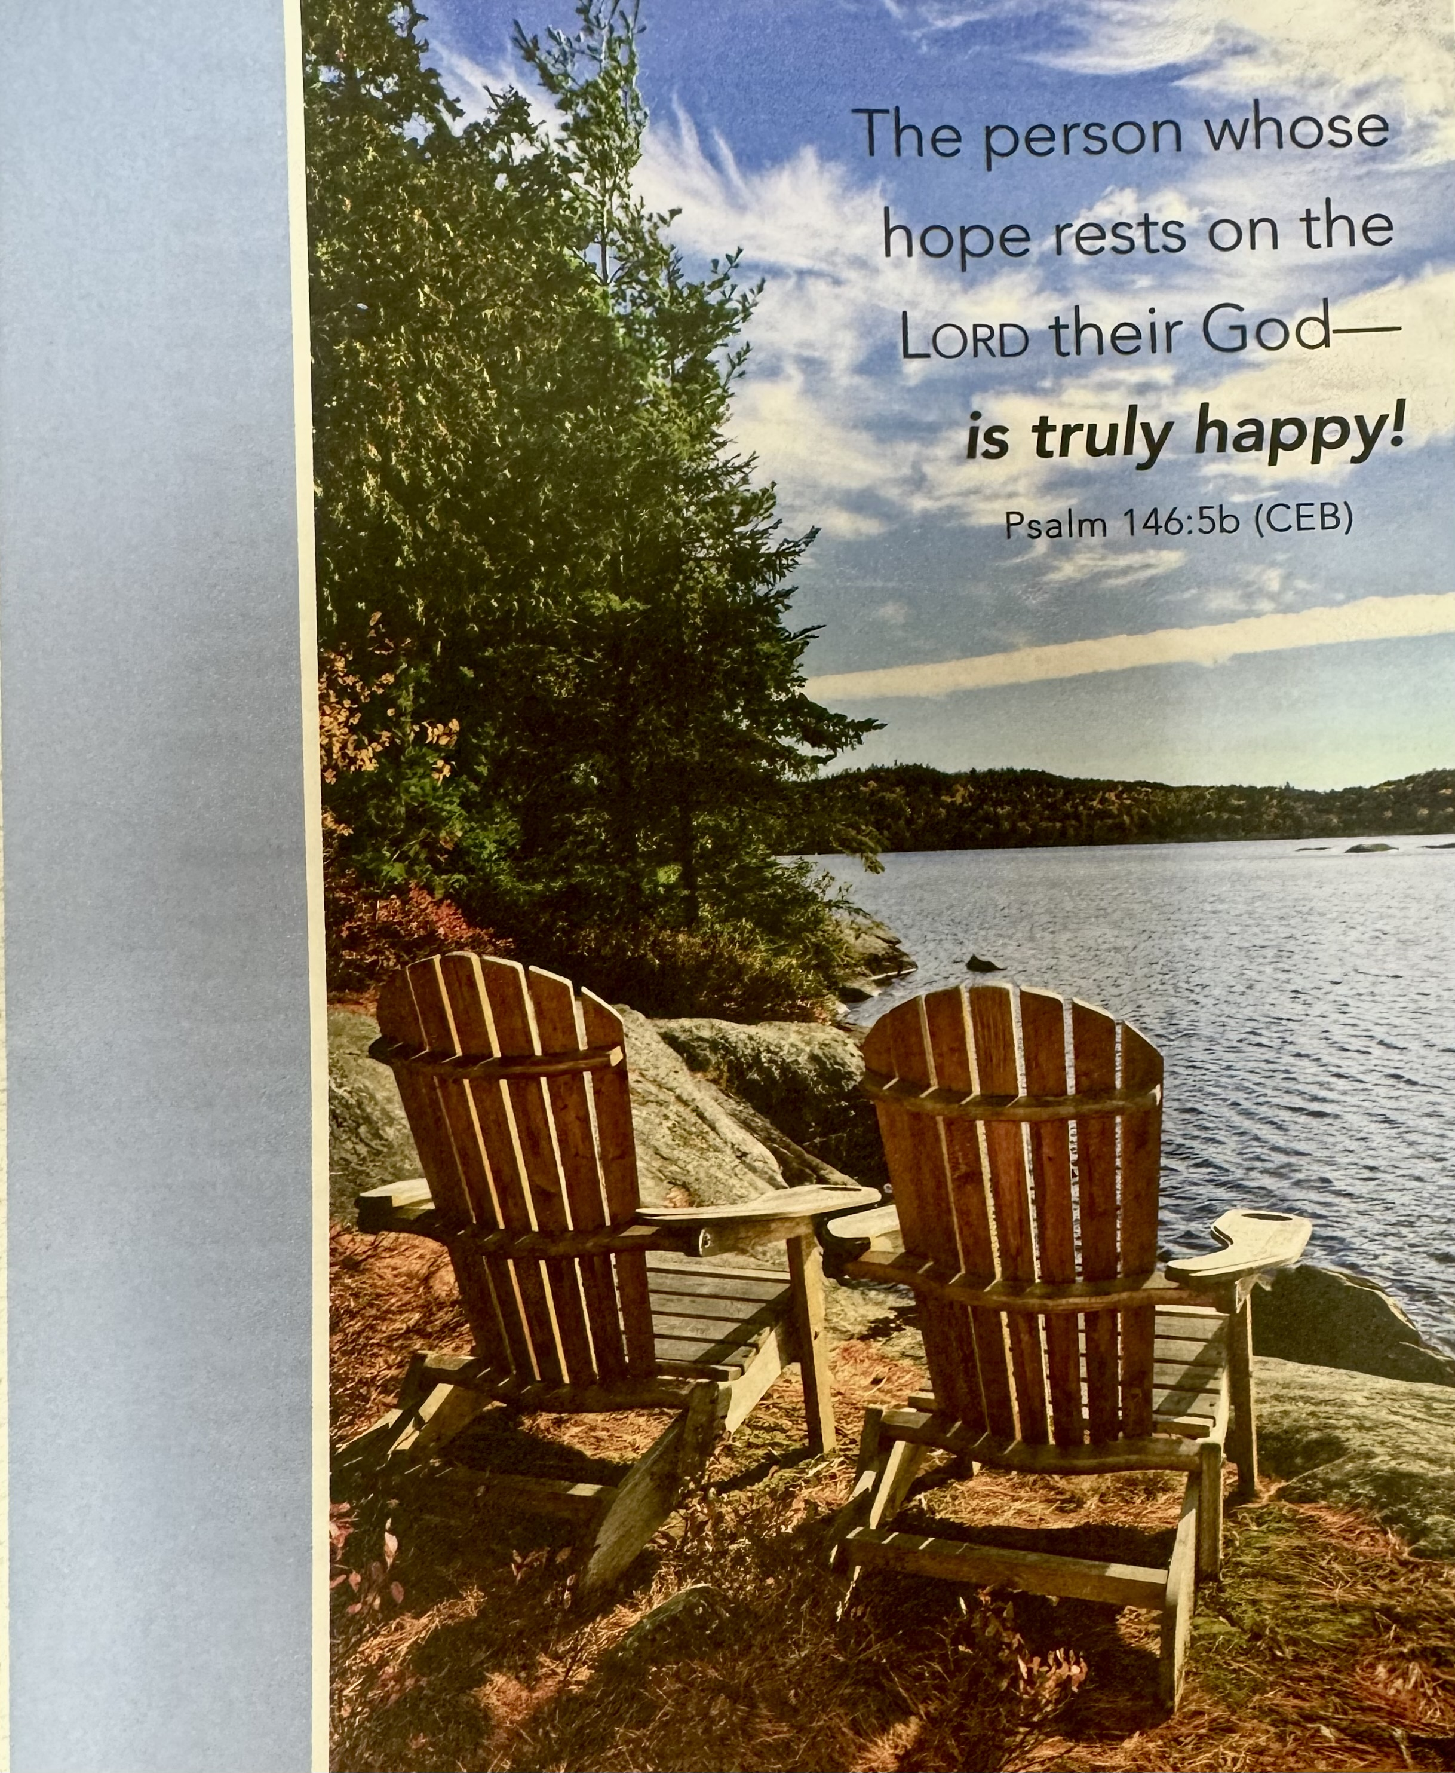

***“ Working Together with All to Connect to God’s Love”***

**First United Methodist Church of Horseheads**

**November 3, 2024**

**All Saints Sunday**

**Greeting and Announcements**

{as this service begins, please use the white prayer cards on the pew-back in front of you if you want something read aloud from the pulpit. During our first hymn, the Ushers will collect cards to be read aloud.}

**Prelude**: **Amazing Grace**  arr. Malcolm Kogut

**\*Call to Worship**

**\*Hymn: For All the Saints** vs. 1,2,4,6 #711 UMH

**Joys and Concerns** Chad Miller

**Silent Prayer**

**Pastoral Prayer**

**The Lord’s Prayer (on screen)** p.#895

**Gift of Music:** Kumbaya                                  arr. Paul Sjolund

**Young Disciples Time**

L. In the beginning, God called the world into being, saying,  
**P. “Let there be light!”**  
L. In the fullness of time, Jesus came from God to us, saying,  
**P. “I am the Light of the world.”**  
L. In our everyday life, we see the work of the saints,  
**P. The ones in whom God’s light shines.**  
L. So let us give thanks for the saints this day,  
**P. And let us worship God.**  
L. We gather this morning to remember our call:  
**P. To do justice, to love kindness, and to walk humbly with God.**  
L. We bring with us the events of the week in the world and in our lives,  
**P. Trying to know how to be just and loving and humble in the midst of it all.**  
L. We gather here, and see those who are doing justice, who are kind beyond measure, who set the example for humility.  
**P. With gratitude for living saints, with thankfulness for the purpose of faith, let us worship God.**

**Words of Assurance**

**Joys and Concerns**

**Silent Prayer**

**Pastoral Prayer**

**The Lord’s Prayer (on screen)** p.#895

**Gift of Music:** Come to the Water Foley/Schrader

**Scripture: Deuteronomy 6: 1-9**  p.#

Leader: The word of God for the people of God

*People: Thanks be to God!*

**\*Hymn:** Pass Me Not, O Gentle Savior#351 UMH

**Scripture: Hebrews 8:6-13** p#47

Leader: The word of God for the people of God

*People: Thanks be to God!*

**Sermon: God’s Writing on Our Hearts**

**Offering**

**Offertory Music:** The Fall of the Leafe Martin Peerson

**Doxology**

**\*Hymn:** Now Praise the Hidden Love of God #2027 FWS

**Benediction**

**Postlude:** Fugue in GFelix Mendelssohn

[Please feel free to be seated and enjoy the Postlude]

*indicates please stand, if able

UMH = red hymnal FWS =   black songbook

**\*Unison Prayer:**

Beloved God,  
who was known to our mothers and fathers,  
and even to our spiritual forebears,  
have mercy on us.  
We do not always love as you would have us love.  
We do not always do as you would have us do.  
In our stubbornness,  
we turn from you when we should turn toward you.  
Hold us, dear One –  
comfort us when we mourn the passing of friends and family,  
and help us to know that they are rejoicing in your presence.  
We praise you for the grace you shower on us,  
constantly forgiving our errors,  
especially the ones that we don’t share with any but you.  
Hear the silent fears and worries of our hearts. And spread your mercies upon us once again. In the name of Jesus Christ, Amen.

**Rememberance of the Saints**

Mary Brown

Kent Lamourex

Constance Breed

Andrea Karabaich

Walter Price

Marolyn Hackett

Susan Carpenter

Deborah Madison

Walter Price

Cynthia Stansfield

Pauline Hardenburg Jan Aiello

Marjorie Bates Hamlin Carol Ochab

Elizabeth Chilson Judy Augustine

Bob Joralemon Sharon Joralemon

Bob Weiss Mary Ann Weiss

Announcements Nov. 3rd, 2024

*Flowers on the altar are given to the Glory of God*

Welcome to Worship today! If you are visiting today with us, please stop by the visitor’s table just outside the sanctuary. There is a gift bag there for you!

**Sunday, Nov. 3rd:**

All Saints Sunday, Communion, Daylight Savings Time (Turn clocks back)

10:45am Sunday School: Grades k-8 Fellowship Hall, Jr. High-Class Rm 18,

Parent Class-Rm 21, Adult Sunday School in the large conference room.

**Tuesday, Nov. 5th:**

Chicken and Biscuit Dinner, 4-6pm or until gone. (Drive through Only)

**Wednesday, Nov. 6th:**

5:30pm, Stephen Ministry, Rm. 12

6:30pm, Faith Builders, SCR

**Thursday, Nov. 7th:**

6:30pm, Outreach, LCR

**Saturday, Nov. 9th:**

4pm, Choir Practice, CR

**Sunday, Nov. 10th:** Veteran Sunday

10:45am, Ministry Audit report in the Sanctuary. (See below for details)

**All Saints Candles:** If you requested a candle to be lit today, please take one home with you after the service. They will be on the altar until Monday. If you do not get it on Sunday, you can find one in the narthex by the office window during the week. If you know of someone who requested a candle and is not able to get to the church, please take one to them.

**Election Day Chicken and Biscuit Dinner:** Dinners are $12 each. Serving begins at 4pm until 6pm, or until gone. You can stay in your car and follow the directions of the attendants in the parking lot. All proceeds benefit the United Women in Faith Missions.

**David Peckham:** I will be playing a concert at 1st Presbyterian in Elmira on Friday November 8 at 7:30 pm. Lots of variety, reflective and dynamic music on an instrument that I created about 15 years ago. Free will offering. Fun music!

**Joys and Concerns**

**Silent Prayer**

**Pastoral Prayer**

**The Lord’s Prayer (on screen)** p.#895

**Gift of Music:** Sweet are the Prayers of a Friend Pepper Choplin

**Scripture: Deuteronomy 6: 1-9** p.#163

Leader: The word of God for the people of God

*People: Thanks be to God!*

**\*Hymn:** Let Us Plead for Faith Alone#385 UMH

**Scripture: Hebrews 8:6-13** p.#222-223

Leader: The word of God for the people of God

*People: Thanks be to God!*

**Sermon: God’s Writing on Our Hearts**

**Communion:** We offer an Open Table to all who are willing to be open to Christ!

Our Offering will be received in the plate, as you come forward for communion.

**Communion Music:**

**\*Hymn:** I’ll Fly Away #2282 FWS

**\*Benediction**

**Postlude:** At the River arr. Jon Spong

[Please feel free to be seated and enjoy the Postlude]

*indicates please stand, if able

UMH = red hymnal FWS =   black songbook

**Thanksgiving gift cards** will help families in need. Our collection of funds will begin on Oct. 27th- Nov. 24th. If you know of a family who can use a gift card for a local grocery store, please give the information to Cindy Ellis or the Church Office as soon as possible. We need your help with the money for the gift cards. Please put a check/cash in the offering plate (checks written to the church with Thanksgiving Gift Cards on the memo line. If you prefer cash, please put in an envelope with Thanksgiving gift cards on the front.) We will give the cards to the families the week before Thanksgiving so they can purchase the food items they will enjoy. Thank you for your generosity at this “GRATEFUL” time of year.

**Christmas Outreach:** Where has the year gone? It would be nice if we could slow time down. Since we can’t, the seasons keep changing. As do the needs of those around us and the Outreach Committee is looking ahead. The season of Christmas should be a time for joy yet may be a difficult time for those who are struggling due to unforeseen circumstances.  If you know a struggling family, please complete a Christmas Giving Tree Application which is available outside the office starting Oct. 27. Forms must be completed and returned to the Church Office by Sunday, Nov. 24, 2024.   Thank you.

**Nov. 10:** Veterans, families, and friends, we would like to invite you to join us for our Sunday Service, Nov. 10, to be recognized and honored for your service. A coffee hour will follow. We look forward to seeing and honoring you.

Also, that day we will hear the church ministry audit report after the service; plan to stay for this brief report about the future direction of our church!

**Calling all Pie Bakers:** The Mission Pie Sale will be held on Sunday, November 17, and we need lots of homemade pies! Proceeds will go to support our missionaries and their projects. Please help by making a pie and/or taking one home for a $10 donation. You won’t want to miss the November 17 church service where Pastor Jeff will be auctioning one of the delicious pies!

**Annual Coat Give Away:** Karren’s Clothing Cupboard along with Outreach has started our coat give away. If you have a coat, you do need anymore and it is in good to excellent condition, for infants through adults, all sizes. We would love to help you find a new home for it. Please, no wool or dry clean only. Coats are now located three different locations. Find them in the narthex, near the chapel and across from Karren’s Clothing Cupboard. Thank you for all your support.

**Winter Fantasy is coming.** We have several people that are donating to the tables for Winter Fantasy. Remember to price your items and make a list of your donations to give us and after the day remember to pick up unsold, (if any), to use for your Christmas giving. *All proceeds will go toward the kitchen update*. You can contact Mary Jane Austin (607-739-4928) or Ande Tubbs (607-739-7082) if you have questions. Thank you.

**Our Church Council** decided last Spring to take a deep dive into our effectiveness as a church.

We want to grow in number and reach more people with God’s love but are unsure how to do it. A small group was formed to look at our spiritual life, heritage, programs, staffing and future opportunities in the Horseheads area. Please come to hear the report and change recommendations for our church on Sunday, November 10th after worship in the sanctuary. In worship that day we will recognize our veterans in the service and at the coffee hour. Then we will return to the sanctuary for a short presentation on the future direction of our ministries. Please join us.

**Events For Veterans:** (Any questions please see Harold Smith)

*CELEBRATION AT CENTER STREET: Thursday, Nov. 7th at Center Street Elementary School, 1 Raider Ln, Horseheads, NY, from 9:30-10:30am. Call 607-795-2580 to register. We welcome all those who participate in our special event to join us for refreshments immediately following the celebration.

\***Veterans are invited to join us** as Finn Academy honors our service men and women with an expression of kindness and gratitude. Scholars and staff would be honored to ‘serve’ you a VETERAN’S BREAKFAST, Friday, Nov. 8th at 8:30-10am at Finn Academy, 610 Lake Street, Elmira, NY 14901. An RSVP by Oct. 31st would be appreciated to melissawildrick@finnacademy.com or 607-737-8040.

\***PHOENIX ACADEMY VETERANS’ CELEBRATION**, Friday, Nov. 8th. Please join us for a “drive thru” celebration. All vehicles will line up at the Fresh Start Church parking lot, across the street from the former Paramount Lanes, at noon, 2447 Corning Road, Elmira Heights. Staff and students will greet Veterans and serve a take-out lunch. Kindly RSVP by Thursday, Nov. 7th, to Cathy Pelchar at 607-426-0785. In case of inclement weather, the celebration will take place inside GST BOCES, Building 1, on the same date and time.

\***November food pantry requests:** Canned Pumpkin, Jiffy pie crust mix, stuffing, canned yams, instant mashed potatoes, gravy, Apple Pie filling.

On the Calendar for December

* Christmas Events/Concerts
* Winter Fantasy Craft Show, December 7th, 9am to 3pm
* Lessons and Carols, December 8th at 5pm in our Sanctuary
* Crystal Chords Christmas Concert, December 17th, 6:45-8:15pm in our Sanctuary
* Be part of the Living Nativity (Schedule coming soon)