**Pastor:** Rev. Dr. Jeff McDowell

**Pastor’s Email:** [pastorjeffmcd@yahoo.com](mailto:pastorjeffmcd@yahoo.com)

**Music Director:**  David Peckham

**Liturgist:** Maureen Nicolo

**Greeters:** Doris Vaughn; Ginny Miller

**Ushers:** Guerry and Alberta Howard; Chad and Jennifer Miller

**Secretary:** Sandy Crane

**Church Phone:** (607) 739-1943

**Email:** [office@horseheadsumc.org](mailto:office@horseheadsumc.org)

**Production Team**: Larry Crandell, Bob Aiello, Bob & Jamie Olcott

**Production Team e-mail:** production@horseheadsumc.org

**Check us out on our Web site, Sundays at 9:30am**

*Facebook: Horseheads United Methodist Church

*You Tube: Hh 1st United Methodist Church



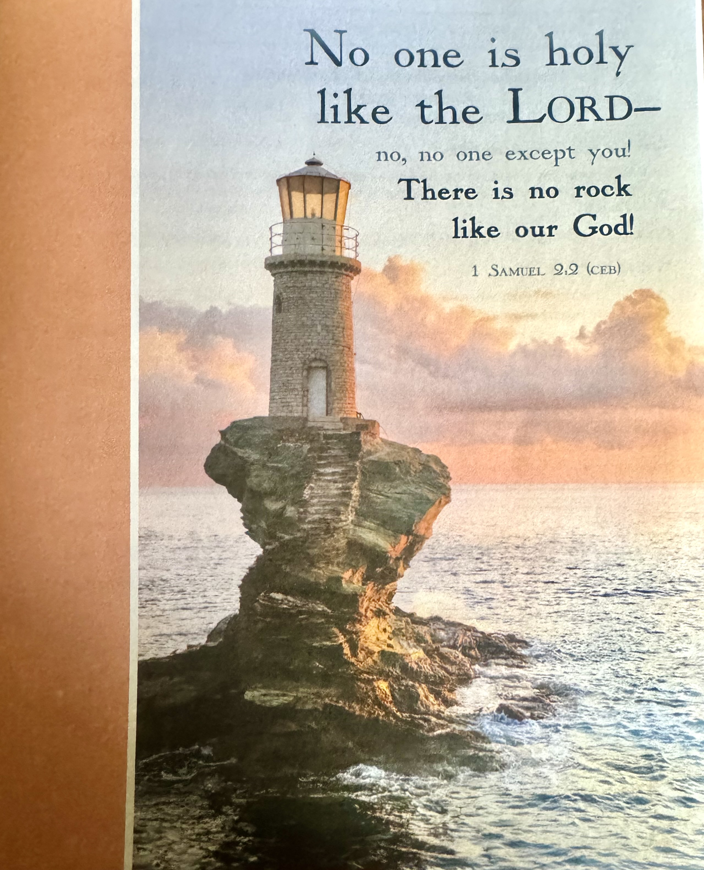

***“ Working Together with All to Connect to God’s Love”***

**First United Methodist Church of Horseheads**

**November 17, 2024**

**Greeting and Announcements**

{as this service begins, please use the white prayer cards on the pew-back in front of you if you want something read aloud from the pulpit. During our first hymn, the Ushers will collect cards to be read aloud.}

**Prelude**: Song Without Words, No. 7                    Felix Mendelssohn

**\*Call to Worship**

**\*Hymn:** All Things Bright and Beautiful #47 UMH

**Unison Prayer:**

**Joys and Concerns** Chad Miller

**Silent Prayer**

**Pastoral Prayer**

**The Lord’s Prayer (on screen)** p.#895

**Gift of Music:** Kumbaya                                  arr. Paul Sjolund

**Young Disciples Time**

Leader: Children of God, when wars and rumors of wars circle all around, Jesus says:

**People: Do not be alarmed. This is not the end.**

Leader: When earthquakes, hurricanes, fires, famines, and floods produce chaos and destruction, Jesus says:

**People: Do not be alarmed. The Lord is at hand.**

Leader: When misinformation and disinformation try to dismantle relationships of trust in our families, churches, cities, and nation, Jesus says:

**People: Do not be alarmed. This is not the end.**

Leader: Children of God, whatever leaves you feeling unsteady, insecure, scared, and confused today--do not be alarmed. This is not the end.

**People: We come to worship God who inscribes our ending, our beginning, and everything in-between in Love. Thanks be to God! Amen.**

Oh Lord we come to you again, asking for grace and mercy in our times of need. We are not the ones who can provide all that we need to live in this world and follow you. But with your help, we can become strong followers of Christ, making a difference right where we live. Help us again today to be bold in our witness, loving in our words, active in our good works to help everyone who comes through these doors. And then, inspire us to reach outside this lovely building to bring God’s love to all the world. For the sake of Christ Jesus we pray, Amen.

**Joys and Concerns**

**Silent Prayer**

**Pastoral Prayer**

**The Lord’s Prayer (on screen)** p.#895

**Gift of Music:** With a Voice of Singing Martin Shaw

**Young Disciples Time**

**Scripture: Deuteronomy 8: 7-18** p.#165

Leader: The word of God for the people of God

*People: Thanks be to God!*

**\*Hymn:** What Gift Can We Bring ` #87 UMH

**Scripture: Philippians 4: 6-20** p#198-199

Leader: The word of God for the people of God

*People: Thanks be to God!*

**Sermon: Three Words for Thanksgiving**

**Offering**

**Offertory Music:**  Arioso from Cantata 156 J.S. Bach

**Doxology**

**\*Hymn:**  Leaning on the Everlasting Arms #133 UMH

Benediction

**Postlude:**  March in G Emil LeBlanc

[Please feel free to be seated and enjoy the Postlude]

*indicates please stand, if able

UMH = red hymnal FWS =   black songbook

**Announcements Nov. 17th, 2024**

*Flowers on the altar are given to the Glory of God*

Welcome to Worship today! If you are visiting today with us, please stop by the visitor’s table just outside the sanctuary. There is a gift bag there for you!

**Sunday, Nov. 23rd:**

**10:45am**, Sunday School: Grades k-8 Fellowship Hall, Jr. High-Class Rm 18,

Parent Class-Rm 21, *Adult Sunday School*, Large Conference Room, *Choir*

*Practice* each Saturday at 3pm, CR

**Tuesday, Nov. 19th:**

**1:00pm**, Worship Meeting, SCR

**Wednesday, Nov. 20th:**

**12:00pm,** United Women in Faith, LCR

**2:00pm,** Missions Committee, LCR

**5:30pm,** Stephen Ministry, Rm. 12

**6:00pm**, Staff Parish, LCR *(Notice different time for this month’s meeting)*

**7:00pm,** Church Council *(Notice different week due to holiday)*

Copies of the Ministry Audit, which was shared with the congregation last Sunday, are in the foyer.

CHRISTMAS POINSETTIA ORDERS. (Poinsettia’s will be put on the altar on December 24th.)

         

**CHRISTMAS POINSETTIA ORDERS.**

(Poinsettia’s will be put on the altar on December 24th.)

POINSETTIA ORDER

It is time to begin planning for this Advent season.  The worship Team will be purchasing poinsettias from Emily’s Florist.  Orders may be placed by returning the form to the Church office by November 24th.  The cost is $10 each.

Quantity: _____________

In Memory: ____________________________________________________________________

In Honor: ____________________________________________________________________

GIVEN BY: ___________________________________________________________________

PHONE: _________________________ $ _____________ENCLOSED

PLEASE PRINT ALL INFORMATION CLEARLY

**A big thank you** to all our wonderful pie bakers from the Mission Committee!  Please support our missionary, Florence Mefor in Zimbabwe, with a $10 donation and take home a delicious pie.

**Do you enjoy art?** Doris Vaughn invites you to a reception to view her artwork at the Horseheads Depot on Thursday, Nov. 21, from 1-4pm at 312 W Broad St, Horseheads. Come, enjoy yourself and have some refreshments.

**Soup to go:** Nov.24th pick up soup right after the service. Free will donation. If you have a favorite soup let Jamie Olcott or Jean Paul know. This month Tomato basil and Sausage Florentine (not spicy).

**Thanksgiving gift cards** will help families in need. Our collection of funds will begin on Oct. 27th- Nov. 24th. If you know of a family who can use a gift card for a local grocery store, please give the information to Cindy Ellis or the Church Office as soon as possible. We need your help with the money for the gift cards. Please put a check/cash in the offering plate (checks written to the church with Thanksgiving Gift Cards on the memo line. If you prefer cash, please put in an envelope with Thanksgiving gift cards on the front.) We will give the cards to the families the week before Thanksgiving so they can purchase the food items they will enjoy. Thank you for your generosity at this “GRATEFUL” time of year.

**Christmas Outreach:** Where has the year gone? It would be nice if we could slow time down. Since we can’t, the seasons keep changing. As do the needs of those around us and the Outreach Committee is looking ahead. The season of Christmas should be a time for joy, yet it may be a difficult time for those who are struggling due to unforeseen circumstances.  If you know a struggling family, please complete a Christmas Giving Tree Application which is available outside the office starting Oct. 27. Forms must be completed and returned to the Church Office by Sunday, Nov. 24, 2024.   Thank you.

**Annual Coat Give Away**: Karren’s Clothing Cupboard along with Outreach has started our coat give away. If you have a coat, you do need any more and it is in good to excellent condition, for infants through adults, all sizes, we would love to help you find a new home for it. Please no wool or dry clean only. Coats are now located three different locations. Find them in the narthex, near the chapel and across from Karren’s Clothing Cupboard. Thank you for all your support.

**Karren’s Clothing Cupboard** is still looking for good to excellent winter coats, preferably not wool and men’s jeans, pants sizes 29- 32 waist, children’s clothing in smaller sizes especially and larger sizes for men and women, 1x up. December 8thwill be open after church for anyone wanting to check out our new set up. The sign-up sheet is in entranceway for the month of December.

**Winter Fantasy sign-up sheets are posted in the entranceway**. Please sign up for any donations for the Holy Grounds Kitchen that you could help us with! Please sign up for help setting up tables/chairs on Thursday and cleaning up on Saturday. Any questions please contact Bob Aiello, 607-331-6121, Larry Crandell: 607-731-1816, Janell Sullivan, 607-739-3797 for any Food donations.

**Winter Fantasy Help Needed**: Our list of Vendors for Winter Fantasy has filled the building!! With more calls each day asking for space. Unfortunately, the committee had to turn away some, but all rooms are filled! So please come shop, even to buy just a small ornament or a large lawn decoration, a homemade gift, and of course our own sweet shop has something you should not have but are going to buy anyway! And don’t forget, lunch made by our own Holy Grounds kitchen staff. On December 7th we are asking you, our congregation, to come over to help support the church and the vendors who make our fund raiser the successful event it has become for 22 years now! Please check the Facebook page and share the Winter Fantasy Poster on your own page.

**Our own Winter Fantasy Table:** We have several people that are donating to the tables for Winter Fantasy. Remember to price your items and make a list of your donations to give us and after the day remember to pick up unsold, (if any), to use for your Christmas giving. All proceeds will go toward the kitchen update. You can contact Mary Jane Austin (607-739-4928) or Ande Tubbs (607-739-7082) if you have questions.

**November food pantry requests:** Canned Pumpkin, Jiffy pie crust mix, stuffing, canned yams, instant mashed potatoes, gravy, Apple Pie filling.

**On the Calendar for December**

**Christmas Events/Concerts**

* Winter Fantasy Craft Show, December 7th, 9am to 3pm
* Lessons and Carols, December 8th at 5pm in our Sanctuary
* Crystal Chords Christmas Concert, December 17th, 6:45-8:15pm

in our Sanctuary

* Be part of the Living Nativity (Schedule coming soon)

**Lost and found:** A ring was found in the kitchen and an earring was also found. Also, a ball cap with Tractor supply on it was found in the sanctuary. If you lost these items, please find them in the church office.

**On the Calendar for December**

**\***Christmas Events/Concerts

*Winter Fantasy Craft Show, December 7th , 9am to 3pm

*Lessons and Carols, December 8th at 5pm in our Sanctuary

*Crystal Chords Christmas Concert, December 17th, 6:45-8:15pm

in our Sanctuary

* Be part of the Living Nativity (Schedule coming soon)

