**Pastor:** Rev. Dr. Jeff McDowell

**Pastor’s Email:** [pastorjeffmcd@yahoo.com](mailto:pastorjeffmcd@yahoo.com)

**Music Director:**  David Peckham

**Liturgist:** Kristin Griffiths

**Greeters:** Mike and Maureen Nicolo

**Ushers:** Pauline LeShure; Ande Tubbs; Carolyn Ryan;

Norma Whatman; Carol Crandell

**Secretary:** Sandy Crane

**Church Phone:** (607) 739-1943

**Email:** [office@horseheadsumc.org](mailto:office@horseheadsumc.org)

**Production Team**: Larry Crandell, Bob Aiello, Bob & Jamie Olcott

**Production Team e-mail:** production@horseheadsumc.org

**Check us out on our Web site, Sundays at 9:30am**

*Facebook: Horseheads United Methodist Church

*You Tube: Hh 1st United Methodist Church

Sermon Theme:

Jesus is more than just a private savior we can take or leave for our own comfort. The basics of faith (forgiveness of sin, justification before God, baptism and salvation by faith) must be mastered before we can move on to Christian maturity. Jesus is Savior of all the world! He is the only one giving sight to the blind and healing to the sin-sick soul. Jesus asked Bartimaeus, “What do you want me to do for you?” The answer was obvious, but Jesus may have wanted the man to own his need and state it out loud, for all to hear: “Let me see again.”

Do you need to revisit the maturity of your faith? Do you need to trust God again for the Saving of the whole world? Does your faith move you forward in service, godliness and hope? Turn again for Jesus, our Everything!



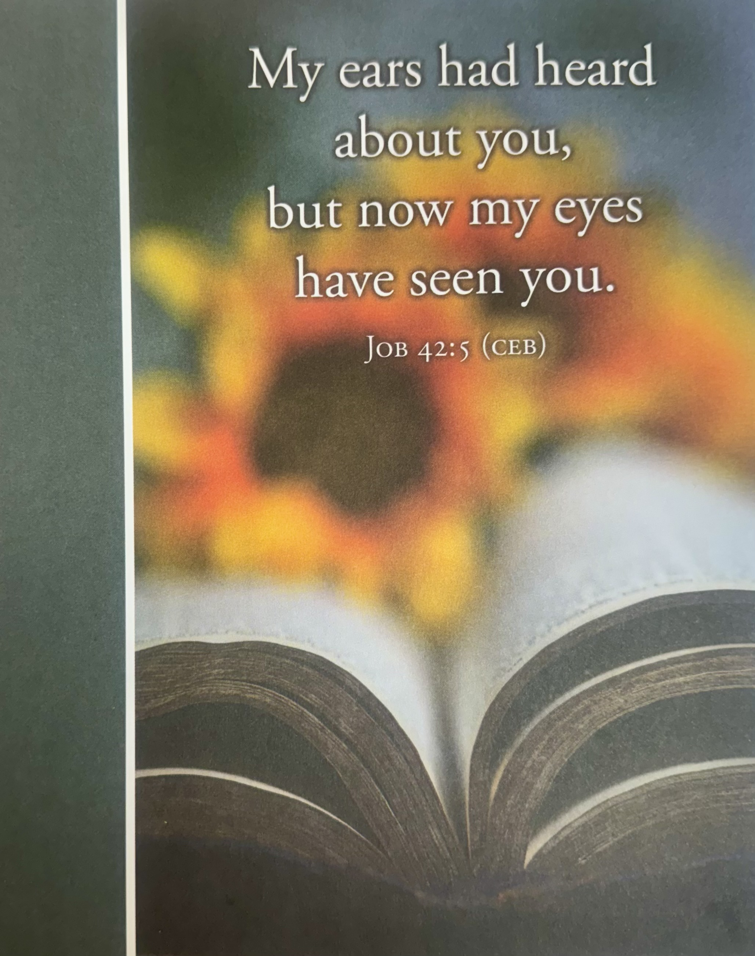

***“ Working Together with All to Connect to God’s Love”***

**First United Methodist Church of Horseheads**

**October 27, 2024**

**Greeting and Announcements**

{as this service begins, please use the white prayer cards on the pew-back in front of you if you want something read aloud from the pulpit. During our first hymn, the Ushers will collect cards to be read aloud.}

**Prelude**: Simple Gifts Fox/Hebble

**\*Call to Worship**

**\*Hymn:** A Mighty Fortress is Our God #110 UMH

**\*Unison Prayer:**

**Joys and Concerns** Chad Miller

**Silent Prayer**

**Pastoral Prayer**

**The Lord’s Prayer (on screen)** p.#895

**Gift of Music:** Kumbaya                                  arr. Paul Sjolund

**Young Disciples Time**

L: One voice: Jesus is in our midst. Jesus, our healer, deliverer, and friend, is here.  
**P: Many voices**: **We have heard so many good things about him, but we long  
to meet him, to encounter him ourselves.**

L: One voice: Call out to him, and do not be silent. Like Bartimaeus, shout to him and do not allow anyone to silence your voice. Cry out and tell Jesus what you need!  
**P: Many voices**: **Jesus, Son of David, have mercy on us! We need a touch from you! Touch me; touch us in our need, which we lift right now in our hearts!**

L: One Voice: In this time of worship, celebrate God’s goodness! In this time celebration of worship, know that Jesus touched your place of need. Hallelujah! **Amen!**

When we want to be a church ever-reforming, yet cling to comfortable ways:  
**Jesus, Son of David, have mercy on us!**

When we want to honor your “still speaking voice,” but are fearful of insights which challenge old assumptions:  
**Jesus, Son of David, have mercy on us!**

When we want to live into Jesus’ dream of oneness, but fail to listen to voices of difference:  
**Jesus, Son of David, have mercy on us!**

**Words of Assurance**

**Joys and Concerns**

**Silent Prayer**

**Pastoral Prayer**

**The Lord’s Prayer (on screen)** p.#895

**Gift of Music:** Come to the Water Foley/Schrader

**Scripture: Hebrews 5:7-14**  p.#220-221

Leader: The word of God for the people of God

*People: Thanks be to God!*

**\*Hymn:** Pass Me Not, O Gentle Savior#351 UMH

**Scripture: Mark 10:46-52** p#47

Leader: The word of God for the people of God

*People: Thanks be to God!*

**Sermon: Jesus, Our Everything!**

**Offering**

**Offertory Music:** The Fall of the Leafe Martin Peerson

**Doxology**

**\*Hymn:** Now Praise the Hidden Love of God #2027 FWS

**Benediction**

**Postlude:** Fugue in GFelix Mendelssohn

[Please feel free to be seated and enjoy the Postlude]

*indicates please stand, if able

UMH = red hymnal FWS =   black songbook

Words of Assurance

Take heart, get up; Jesus is calling to us!  
We trust in the one who has guided the church for two millennia.  
Through Christ, God forgives us our failings,  
and continues to call us into a community of mutual love and forgiveness.  
In the name of Jesus Christ, you are forgiven!  
**In the name of Jesus Christ, you are forgiven!  
Glory to God! Amen.**

**Announcements Oct 27th, 2024**

***Flowers on the altar are given to the Glory of God and***

***for everyone affected by the recent hurricanes and tornadoes from Sylvia Sullivan and family.***

Welcome to Worship today! If you are visiting today with us, please stop by the visitor’s table

just outside the sanctuary. There is a gift bag there for you!

**Sunday, Oct. 27th:**

10:45amSunday School**:** Grades k-8 Ffellowship Hall, Jr. High-Class Rm 18, Parent Class-

Rm 21, Adult Sunday School in the large conference room.

**Wednesday, Oct 30th:**

5:30pm, Stephen Ministry, Rm. 12

**Saturday, Nov. 2nd:**

4:00pm, Choir Practice, CR

**Sunday,** Nov. 3rd, All Saints Sunday

**All Saints Sunday:** Next week is November 3rd and our church will celebrate All Saint’s Sunday to remember family and friends we have lost. We have two ways you are asked to participate.

1. **List for Bulletin:** For those members who have died in this last year, please submit the names of those you would like to be remembered to the church office (607-739-1943) by Monday, October 28th.  A candle will be lit, and the name of each person will be listed in the bulletin and read during the service.  After the worship service, please take the candle home.  Any candles left will be available for you to pick up at the church this week.
2. **All Saints Memorial Prayer Card*s:*** To honor all those we have lost (more than one year ago), use a memorial prayer cardin the bulletin. Fill one out today and place in the offering plate. Next Sunday, we will have these on our communion table and then display them in our prayer garden after the service. There is no cost for this expression of loving memorials. Consider purchasing a brick for the garden to remember them long term.

**Karren’s Clothing Cupboard:** November Volunteer sign up calendar is in the main entrance. We need you!

**The November newsletter** has been sent out. Please let the church office know if you did not receive it. Copies of the newsletter are in the narthex. If you wish to submit an article for the newsletter, please remember the deadline for the newsletter is due by the third Wednesday of the month.

**Announcements Oct 27th, 2024**

***Flowers on the altar are given to the Glory of God and for***

***everyone affected by the recent hurricanes and tornadoes from Sylvia Sullivan and family.***

Welcome to Worship today! If you are visiting today with us, please stop by the visitor’s table just outside the sanctuary. There is a gift bag there for you!

**Sunday, Oct. 27th:**

10:45amSunday School**:** Grades k-8 Ffellowship Hall, Jr. High-Class Rm 18, Parent

Class-Rm 21, Adult Sunday School in the large conference room.

**Soup to go,** kitchen after the service.  Serving:  Hanks Pumpkin and Turkey Chili.

**Wednesday, Oct 30th:**

5:30pm, Stephen Ministry, Rm. 12

**Saturday, Nov. 2nd:**

4:00pm, Choir Practice, CR

**Sunday,** Nov. 3rd, All Saints Sunday

**All Saints Sunday:** Next week is November 3rd and our church will celebrate All Saint’s Sunday to remember family and friends we have lost. We have two ways you are asked to participate.

1. **List for Bulletin:** For those members who have died in this last year, please submit the names of those you would like to be remembered to the church office (607-739-1943) by Monday, October 28th.  A candle will be lit, and the name of each person will be listed in the bulletin and read during the service.  After the worship service, please take the candle home.  Any candles left will be available for you to pick up at the church this week.
2. **All Saints Memorial Prayer Card*s:*** To honor all those we have lost (more than one year ago), use a memorial prayer cardin the bulletin. Fill one out today and place in the offering plate. Next Sunday, we will have these on our communion table and then display them in our prayer garden after the service. There is no cost for this expression of loving memorials. Consider purchasing a brick for the garden to remember them long term.

**Karren’s Clothing Cupboard:** November Volunteer sign up calendar is in the main entrance. We need you!

**The November newsletter** has been sent out. Please let the church office know if you did not receive it. Copies of the newsletter are in the narthex. If you wish to submit an article for the newsletter, please remember the deadline for the newsletter is due by the third Wednesday of the month.

**Thanksgiving gift cards** will help families in need. Our collection of funds will begin on Oct. 27th- Nov. 24th. If you know of a family who can use a gift card for a local grocery store, please give the information to Cindy Ellis or the Church Office as soon as possible.

We need your help with the money for the gift cards. Please put a check/cash in the offering plate (checks written to the church with Thanksgiving Gift Cards on the memo line. If you prefer cash, please put in an envelope with Thanksgiving gift cards on the front.) We will give the cards to the families the week before Thanksgiving so they can purchase the food items they will enjoy. Thank you for your generosity at this “GRATEFUL” time of year.

**The Alzheimer’s Association** is having a free daylong conference/worship for caregivers and friends of people experiencing mental decline. The date is Thursday, Nov. 7th, at the Horseheads Elks Club. Various speakers and agencies will present in areas of questions and concerns. Join Pastor Jeff and other church members who are going. Pre-registration is required. Call 800-272-3900. Any questions please contact JoAnn Hunt (607) 259-0817.

**Nov. 10: Veterans, families, and friends,**we would like to invite you to join us for our Sunday Service, Nov. 10, to be recognized and honored for your service.  A coffee hour will follow.  We look forward to seeing and honoring you.

Also, that day we will hear the **church ministry audit** report after the service; plan to stay for this brief report about the future direction of our church!

**Winter Fantasy is coming soon**. We would like to have a table of donated items from church members that we would sell and give the money toward the kitchen improvements. Any item of yours left you would take back to use. Please, if you can help, let Mary Jane Austin (607-739-4928) or Ande Tubbs (607-739-7082) know. Thank you.

**Events For Veterans: (Any questions please see Harold Smith)**

**CELEBRATION AT CENTER STREET:** Thursday, Nov. 7th at Center Street Elementary School, 1 Raider Ln, Horseheads, NY, from 9:30-10:30am. Call 607-795-2580 to register. We welcome all those who participate in our special event to join us for refreshments immediately following the celebration.

**Veterans are invited** to join us as Finn Academy honors our service men and women with an expression of kindness and gratitude. Scholars and staff would be honored to ‘serve’ you a VETERAN’S BREAKFAST, Friday, Nov. 8th at 8:30-10am at Finn Academy, 610 Lake Street, Elmira, NY 14901. An RSVP by Oct. 31st would be appreciated to [melissawildrick@finnacademy.com](mailto:melissawildrick@finnacademy.com) or 607-737-8040.

**Phoenix academy veterans’ celebration**, Friday, Nov. 8th. Please join us for a “drive thru” celebration. All vehicles will line up at the Fresh Start Church parking lot, across the street from the former Paramount Lanes, at noon, 2447 Corning Road, Elmira Heights. Staff and students will greet Veterans and serve a take-out lunch. Kindly RSVP by Thursday, Nov. 7th, to Cathy Pelchar at 607-426-0785. In case of inclement weather, the celebration will take place inside GST BOCES Building 1, on the same date and time.

