**Production Team**: Larry Crandell, Bob Aiello, Bob & Jamie Olcott

**Production Team email**: production@horseheadsumc.org

**Music Director:** David Peckham

**Greeters:** Betty Drake & Mary Daniels

**Ushers:** D. Williams; D. Tubbs; C. Miller; T. Bolt

**Pastor:** Rev. Dr. Jeff McDowell

**Pastor’s Email:** [pastorjeffmcd@yahoo.com](mailto:pastorjeffmcd@yahoo.com)

**Secretary:** Sandy Crane

**Church Phone:** (607) 739-1943

**Web site:** www.hhdsumc.org

**Email:** [office@horseheadsumc.org](mailto:office@horseheadsumc.org)

**See us live on Facebook & You Tube, Sundays at 9:30am**

**Check us out anytime on our Web site, You Tube or Facebook**

**Facebook: Horseheads United Methodist Church**

**You Tube: Hh 1st United Methodist Church**

**Sermon Theme:**

History shows that Christians often follow a pattern of following Jesus closely and then backing off, leaving the narrow path of faith and a godly life. The bible says in James that a double-minded person is unstable in all their ways.

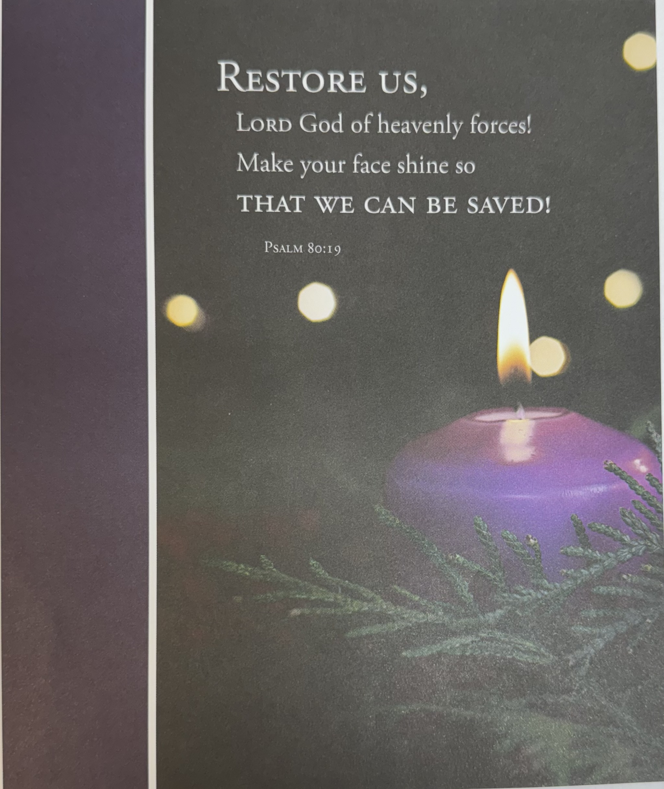

***“ Working Together with All to Connect to God’s Love”***

***“Working Together with All to Connect to God’s Love.”***

**Horseheads First United Methodist Church**

**First Sunday of Advent**

**Communion Sunday**

**December 3, 2023**

**Greeting and Announcements**

{as this service begins, please use the white prayer cards, on the pew-back in front of you if you want something read aloud from the pulpit. During our first hymn, the Ushers will collect cards to be read aloud.}

**Prelude:** As the Dark Awaits the Dawn David Lasky

**\*Call to Worship**

We gather again at the end of the year to wait for the Christ child anew.  
**We wait in fervent hope of the coming of the Savior.**

We wait, and we remember the astounding things God has done to save God’s people.  
**We wait in loving hope of the coming of the Savior.**

We wait, and we pay attention for signs of God’s justice and mercy turning the world upside down.  
**We wait in expectant hope of the coming of the Savior.**

We wait, and in our waiting, we learn to live as people of God’s promise.  
**Let us worship in the fulfilling hope of Jesus Christ, the coming Savior. Amen.**

**\*Hymn:** Come, Thou Long-Expected Jesus #196 UMH

**Lighting of the Advent Wreath**

Reader 1: In the days of exile and uncertainty, the prophet Isaiah cried out:

O that you would tear open the heavens and come down, so that the mountains would quake at your presence. As when fire sets twigs ablaze and causes water to boil, come down to make your name known to your enemies and cause the nations to quake before you! For when you did awesome things that we did not expect, you came down, and the mountains trembled before you. (Isaiah 64:1-3)

Reader 2: In the midst of our own encounters with uncertainty and upheaval and our longing for deliverance, Jesus calls to us, “Therefore, keep awake—for you do not know when the master of the house will come” (Mark 13:35).

**Congregation:** **We wait as people surprised again and again by God who shakes us out of our complacency and wakes us up to the work of the kingdom all around us.**

Reader 1: We light this candle as a sign of our shocking hope. May we stay awake to God’s activity in the world as we wait in expectation that even now God is with us, working to restore us to the fullness of life with God and one another. Amen.

***Light the first candle of the Advent wreath.***

**\*Unison Prayer**

God of justice and peace, from the heavens, you rain down mercy and kindness, that all on earth may stand in awe and wonder before your marvelous deeds. Raise our heads in expectation, that we may yearn for the coming day of the Lord and stand without blame before your Son, Jesus Christ, who lives and reigns for ever and ever. **Amen.**

**Joys and Concerns**

**Silent prayer**

**Pastoral prayer**

**Lord’s Prayer** [on screen] p.#895

**Gift of Music:** Watchman, Tell Us of the Night John Ness Beck

**Scripture: Psalm 80:1-7, 17-19** p.#540-541

Leader: The word of God for the People of God

*People: Thanks be to God!*

**\*Hymn:** Because Thou Hast Said  #635 UMH

**Scripture: I Corinthians 1:3-9** p.#166

Leader: The word of God for the People of God

*People: Thanks be to God!*

**Sermon:** Coming Closer to Jesus

**Communion**

**\*Hymn:** I Want to Walk as a Child of the Light #206 UMH

**\*Benediction**

**Benediction Response: Prepare Ye**

**Postlude: Prepare the Way, O Zion** Robert Lau **[Please feel free to be seated and enjoy the Postlude}**

**\*indicates please stand, if able**

UMH = red hymnal FWS =   black songbook

**Announcements December 3, 2023**

*Flowers on the altar are given to the Glory of God with thoughts and prayers for the people of Israel.*

**Calendar**

**12/3:** Lessons & Carols, 5pm

**12/5:** Light from Afar, Advent Book Study, 9am, LCR

**12/6:** United Women in Faith Christmas Party, Noon, FH

**12/6**: Stephen Ministry, 5:30, Rm. 12

**12/7**: Outreach, 6:30, LCR

*No Faith Builders Meeting this week.*

**Choir Practice** every Saturday at 3pm *(Choir will practice on 12/2 after Winter Fantasy)*

**Sunday School at 10:45:** Kindergarten-5th grade: Fellowship Hall, Middle School/Confirmation: Chapel, High School: Rm 18, Parent Class: Rm 21, Adult Sunday School: Large Conference Room, The Nursery is available for ages 4 and under.

**Karren’s Clothing Cupboard:** New winter hours, Tuesday 10-12, and Thursday 1-3.

***Adult book Study. Light from Afar*** is a daily Advent devotional that illuminates the season through the unforgettable stories and reflections of four writers from around the world. Authors from Ukraine, Philippines, Brazil, and South Africa share cultural and religious traditions of the Advent season in their daily reflections. Each day's meditation includes a scripture reading, a prayer, an opportunity for reflection, and a link to a song from the author's home country.

A. **Sunday mornings** from 10:45-11:45 in Classroom #21, led by the parenting class. Books provided; all are welcome.

*B.* ***Tuesday mornings*** *from 9:00 – 10:00 a.m. in large conference room,* ***Dec. 5, 12, and 19****, led by Rev. McDowell.*

**An Advent Service of Lessons and Carols.** The Christmas story in music and word. Featuring the combined Church Choirs of St. Mary Our Mother and First United Methodist Church of Horseheads and featuring Brass, Woodwinds, Strings, Bells & Percussion. Here tonight at 5pm in the Sanctuary!

***Lost your calendar or announcement sheet this week? Find it all on the Church Web Site!*** [***www.hhdsumc.org***](http://www.hhdsumc.org)

**Lynch Funeral Home and Barber Funeral Home** sent the church 2024 calendars for you to take. You can find them in the Narthex.

***Soup to Go****: Net Proceeds for the current expenses of our church from our “Soup to Go” last week is $166.00. Special thanks to Jamie Olcott and Jean Paul for all their hard work!*

**Not Playing with a full deck** is back on Dec. 8th. Anyone who would like to play cards, please come join us! Bring your lunch if you want and have some fun and fellowship on Fridays from noon to 2pm.

**Community Event Bulletin Board**: Remember when all those papers that hung in the entranceway and blew all over when the doors opened? You can now find those events for the surrounding area on the bulletin board by the water fountain. If you have an event you would like to put a poster/note up for, please bring to the office and we will hang it up. (If you put a poster there, please take it down when you know the event is over.)

**Announcements:** All announcements for the weekly bulletin need to be in the Church Office by Tuesday at 1pm. Announcements received after Tuesday will go in the following week’s bulletin. Newsletter articles are due by the third Wednesday of the month. For the January newsletter, please send in your articles by Dec. 12th (due to the Christmas holiday).

**History of the Living Nativity** In 1983, Rev. Mary Jo Yaekel and Maureen Nicolo worked together to start the first Living Nativity. They borrowed costumes and built the stable by hand each year. Later many volunteers sewed their own costumes. In 1985, John Bouille offered to construct the stable we use today. Each year, Doug Mayhew gathered a group to rebuild the structure. Our front lawn is the perfect location to show the true meaning of Christmas. Without our church family & friends this tradition of the FUMC would not be possible. Move ahead to 2022, Dylan Maynard built the new stable, for his eagle project. Troop 84 will construct the stable for us to use this year. We offer other churches in the area to participate if they would like to join in. If you would like to participate in this event, please give Sandy a call at the church office and she will schedule you. (607-739-1943). Living Nativity runs December 20-24th.

**Our church is blessed to have a devoted staff**.  They give of their time and talents to ensure jobs well done.  Our staff consists of Pastor Jeff McDowell, Secretary, Sandy Crane, Music Director, David Peckham, Parish Visitor, Cindy Ellis, Superintendent of Buildings, Jamie Olcott, and Lullaby Room, Sarah Woodard.  It has been a tradition at this time of year to give these people a monetary gift to say thank you.  If you would like to make a donation for the staff Christmas Giving, please mark your donation as Christmas Giving and put it in the collection plate or turn it in to the office.  Your generosity is appreciated.

Your staff Parish thanks you, Guerry Howard, Brent Arnold, Fred Daniels, John Young, Gordon Gillette, Ann Rouse, Jan Przybylski, Christina Peklak.

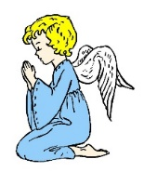You could be a Christmas Angel

when you donate to the Outreach Giving Tree.



[This Photo](https://en.wikipedia.org/wiki/File:Xmas_tree.svg) by Unknown Author is licensed under [CC BY-SA](https://creativecommons.org/licenses/by-sa/3.0/)

The donations are needed by Dec. 10 when gift cards.

will be purchased to help families celebrate the season of love.

Envelopes are available on display in the narthex.

Put checks (with Giving Tree on the memo line)

or cash in an envelope and deposit them in the

Christmas Box, collection plates, or give them to the office.

Blessings to one and all.

**Flowers on the Altar from December 24-31, 2023, are our annual Christmas Poinsettia’s.** Please fill in the order form below if you wish to purchase one for the altar. After Christmas Eve Service, please take your flower home or give it to someone you know. Please submit this form to the Church Office.

**Poinsettia Order Form**

In Honor of: (Print name)___________________________________________________

In Memory of: (Print name)_________________________________________________

Your name/phone *in case of a needed information*:____________________________________________________________________

______________________________________________________________________________

Amount Paid: $______________ (*Checks made out to the church with Poinsettia in the memo line*)

*One person per form please. Please print clearly***. Flowers are $12 each**.

Color: Red _____

White ____

**………………………………………………………………………………………………………………**

**Living Endowment Fund**

In Honor of: (Print name)__________________________________________________

In Memory of: (Print name)________________________________________________

Amount enclosed: $________ (*Checks made out to the church with Living Endowment in the memo line*)

………………………………………………………………………………………………………………..

**Building Fund**

Given By:______________________________________________________________

Amount enclosed: $________ (*Checks made out to the church with Building Fund in the memo line*)