**Production Team**: Larry Crandell, Bob Aiello, Bob & Jamie Olcott

**Production Team email**: production@horseheadsumc.org

**Music Director:** David Peckham

**Liturgis**t:

**Greeters:** Ann and Dave Rouse

**Ushers:** P. LeShure; A. Tubbs; C. Ryan; N. Whatman; C. Crandell

**Pastor:** Rev. Dr. Jeff McDowell

**Pastor’s Email:** [pastorjeffmcd@yahoo.com](mailto:pastorjeffmcd@yahoo.com)

**Secretary:** Sandy Crane

**Church Phone:** (607) 739-1943

**Web site:** www.hhdsumc.org

**Email:** [office@horseheadsumc.org](mailto:office@horseheadsumc.org)

See us live on Facebook & You Tube, Sundays at 9:30am

Check us out anytime on our Web site, You Tube or Facebook

Facebook: Horseheads United Methodist Church

You Tube: Hh 1st United Methodist Church

**Sermon Theme:**

The ancient call of Isaiah was to get ready for the Savior by turning 180 degrees from sin and toward God. Good works accompany a sinner who turns, and justice results from a commitment to doing right by God. John the Baptizer came also with a message of turning away from sin and toward God. These actions get us ready for the Savior to enter our lives. How do we respond to these calls today? First, acknowledge the patterns of your own behavior which have moved you far away from God and / or harmed others. Be honest with yourself and confess it to God with sorrow in your heart. Second, accept God’s forgiveness fully: do not keep beating yourself up. Instead, when you know Jesus died for you to save you from your sins, receive that and let your regrets go. Third, commit to live for Jesus Christ with small daily acts, making a difference in the world. Our privilege this month is getting closer to Jesus. We Can Do It!

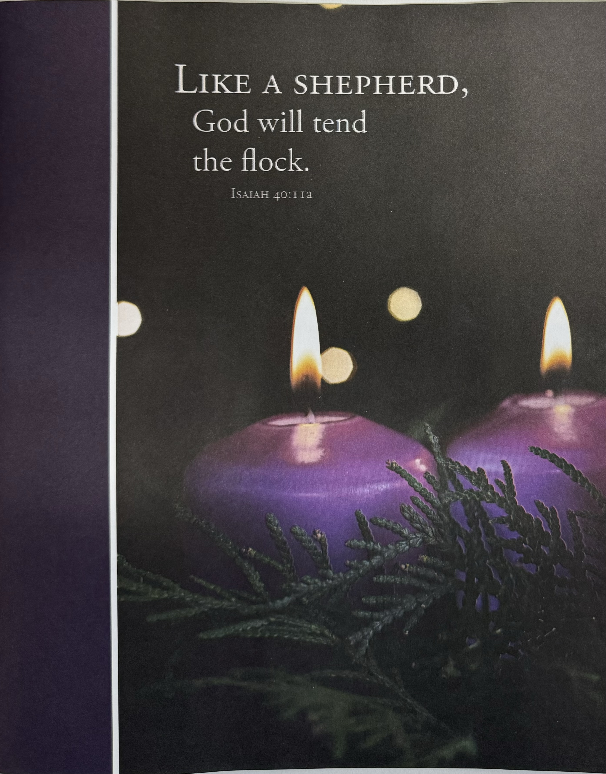

***“ Working Together with All to Connect to God’s Love”***

***“Working Together with All to Connect to God’s Love.”***

First United Methodist Church of Horseheads

**December 10, 2023**

**Greeting and Announcements**

{as this service begins, please use the white prayer cards, on the pew-back in front of you if you want something read aloud from the pulpit. During our first hymn, the Ushers will collect cards to be read aloud.}

**Prelude:** Two settings on Come, Thou Long Expected Jesus          Charles Callahan

**\*Call to Worship**

Come! Listen! A voice cries out: “In the wilderness, prepare the way of the Lord; make straight in the desert a highway for our God.”  
**We come, and we wait in the just peace of the coming Messiah.**

Pay attention! God is removing barriers and leveling the playing field, making a way for all people to witness the glory of the Lord.  
**We pay attention, and we wait in the just peace of the coming Messiah.**

We wait, and we work as God’s landscapers, filling in valleys and making rough places a plain, bringing justice where conflicts and obstacles once reigned.  
**We wait, and we work in the just peace of the coming Messiah.**

As we gather, may we prepare our voices to proclaim and our hands to get messy as our lives declare the coming of our Savior and Comforter.  
**We come to worship and to grow in the just peace of Jesus Christ, the coming Messiah. Amen.**

**\*Hymn:** O Come, O Come, Emmanuel vs 1-3, 6, 7 #211 UMH

**Lighting of the Advent Wreath** Majiros Family

Reader 1: In days when God’s people longed for peace, Isaiah declared, “Comfort, O comfort my people, says your God. Speak tenderly to Jerusalem, and cry to her that she has served her term, that her penalty is paid, that she has received from the Lord's hand double for all her sins” (Isaiah 40:1).

Reader 2: We who gather today also seek comfort and peace, yet we are unsatisfied with ideas of peace that tell us to keep quiet and go with the flow. We long for real peace, true peace, just peace.

**Congregation: We wait as people who yearn for peace that bears the fruit of community, equity, and flourishing for all.**

Reader 1: We light these candles as signs of God’s shocking hope and just peace. May they be beacons, calling us to repent and to live the good news of Jesus Christ as we wait and watch and labor for the day when all people can gather together to worship and glorify God. Amen.

***Light two purple candles of the Advent wreath.***

**\*Unison Prayer**

Merciful God,  
in your gracious presence  
we confess our sin and the sin of this world.  
Although Christ is among us as our peace,  
we are a people divided against ourselves  
as we cling to the values of a broken world.  
The profit and pleasures we pursue  
lay waste the land and pollute the seas.  
The fears and jealousies that we harbor  
set neighbor against neighbor  
and nation against nation.  
We abuse your good gifts of imagination and freedom,  
of intellect and reason,  
and have turned them into bonds of oppression.  
Lord, have mercy upon us;  
heal and forgive us.  
Set us free to serve you in the world  
as agents of your reconciling love in Jesus Christ. Amen.

**Ministry Moment**

**Joys and Concerns**

**Silent prayer**

**Pastoral prayer**

**Lord’s Prayer** [on screen] p.#895

**Gift of Music:** Our Hope Is in Emmanuel                  Victor Johnson

**Young Disciples Time**

**Scripture: Isaiah 40:1-11** p.#667

Leader: The word of God for the People of God

*People: Thanks be to God!*

**\*Hymn:**  Wild and Lone the Prophet’s Voice #2089 FWS

**Scripture:** **Mark 1:1-8** p.#34

Leader: The word of God for the People of God

*People: Thanks be to God!*

**Sermon:** Closer to Jesus, further from sin

**Offering**

**Offering Music** Comfort, Comfort Ye My People            Timothy Albrecht

**\*Hymn:** Lift Up Your Heads, Ye Mighty Gates #213 UMH

**\*Benediction**

**Postlude:** Savior of the Nations, ComeJ.S. Bach [Please feel free to be seated and enjoy the Postlude}

*indicates please stand, if able

UMH = red hymnal FWS =   black songbook

**Announcements December. 10, 2023**

***Flowers on the altar are given to the Glory of God and memory of Robert Brown***

12/10: Coffee hour presented by Karren’s Clothing Cupboard

**12/12:** Light from Afar Advent Book Study, 9am, LCR

**12/12**: Trustee Meeting, 7pm, Rm 11

**12/17:** Soups to go: Cream of broccoli and stuffed "unstuffed" pepper soup.

**12/19**: Crystal Chords Christmas Concert, 6:45pm, Sanctuary

**Choir Practice** every Saturday at 3pm

**Sunday School at 10:45:** Kindergarten-5th grade: Fellowship Hall, Middle School/Confirmation: Chapel, High School: Rm 18, Parent Class: Rm 21, Adult Sunday School: Large Conference Room, The Nursery is available for ages 4 and under.

**Karren's Clothing Cupboard**: Please join us today after church for coffee hour celebrating Karren's Clothing Cupboard 1 year anniversary. The committee that runs the Cupboard is Ida Beard, Barb Burdette, Cheryl Cleveland, Betsy Doan, Teri Hauptman, Hope Mayhew, Theresa McKinley, Carol Smallback and Ande Tubbs.  Without the hard work of each of these people, it would not have been the success it is.

**Giving envelopes**: Your new giving envelopes are in the Narthex. If you did not find yours, please sign the sheet on the clip board or call the church office at 607-739-1943. Please make sure your address is correct. If you could deliver one to someone who cannot get out, please do so.

**Living Nativity.** If you would like to participate in this event, please give Sandy a call at the church office and she will schedule you. (607-739-1943). A sign-up sheet is also in the entranceway. Living Nativity runs December 20-24th.

**Not Playing with a full deck:** Anyone who would like to play cards, please come join us! Bring your lunch if you want and have some fun and fellowship on Fridays from noon to 2pm.

**Our church is blessed to have a devoted staff**.  They give their time and talents to ensure jobs well done.  Our staff consists of Pastor Jeff McDowell, Secretary, Sandy Crane, Music Director, David Peckham, Parish Visitor, Cindy Ellis, Superintendent of Buildings, Jamie Olcott, and Lullaby Room, Sarah Woodard.  It has been a tradition at this time of year to give these people a monetary gift to say thank you.  If you would like to make a donation for the staff Christmas Giving, please mark your donation as Christmas Giving and put it in the collection plate or turn it in to the office.  Your generosity is appreciated.

Your Staff Parish thanks you, Guerry Howard, Brent Arnold, Fred Daniels, John Young, Gordon Gillette, Ann Rouse, Jan Przybylski, Christina Peklak.