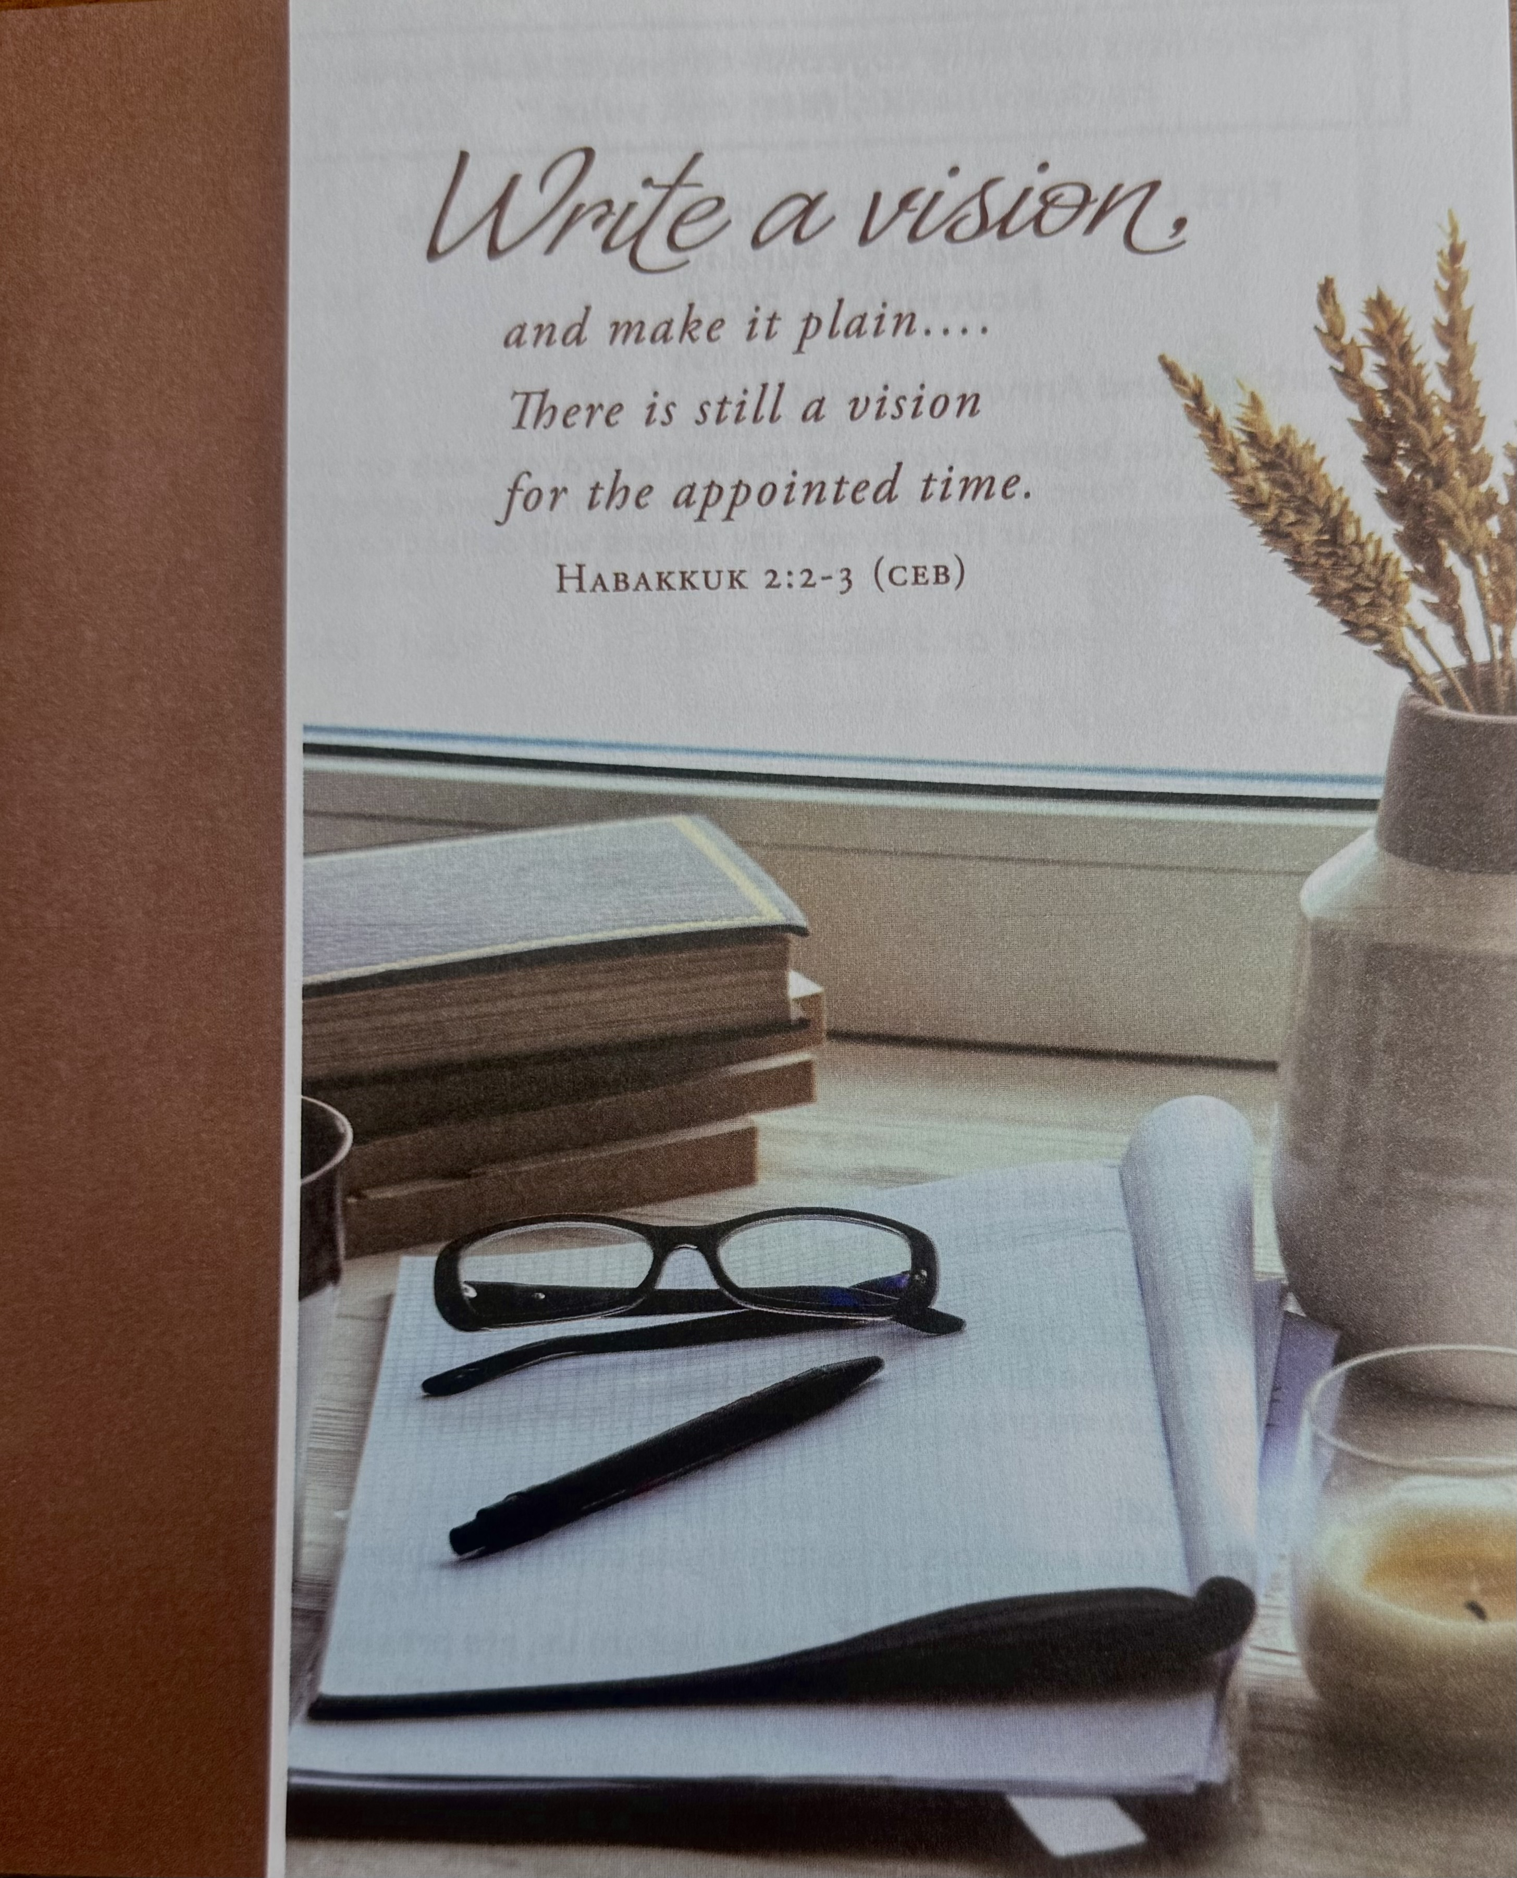
Sermon Theme: We are joined in God's family by faith in God, and His Son Jesus Christ. People from all lands, all languages, all cultures and all time are family, with faith as our spiritual bond. The problem is, we often exclude those we don't understand, and we push them aside, huddle with people like us think our church is complete. But Jesus commissioned us to "go make disciples of all people". God calls us today to expand the borders of our thinking and include people across the globe in our circle of faith. When we do this, we live fully as Christ's body here on earth and give glory to Him in heaven! Open your mind and heart, for The Bible says, "Eye hath not seen, nor ear heard, neither have entered into the heart of man, the things which God hath prepared for them that love him." (I Cor. 2:9)

Pastor: Rev. Dr. Jeff McDowell
Pastor’s Email: pastorjeffmcd@yahoo.com
Music Director: David Peckham
Secretary: Sandy Crane
Church Phone: (607) 739-1943
Email: office@horseheadsumc.org
Ushers: Dick Williams; Dennis Tubbs; Terry Bolt; Chad Miller
Production Team: Larry Crandell, Bob Aiello, Bob & Jamie Olcott
Production Team email: production@horseheadsumc.org
Liturgist: Bob Solsky
Greeters: Doris Vaughn
Web site: www.hhdsumc.org

See us live on Facebook & You Tube, Sundays at 9:30am
Check us out anytime on our Web site, You Tube or Facebook
Facebook: Horseheads United Methodist Church
You Tube: Hh 1st United Methodist Church

*Hymn: Sing with All the Saints in Glory #702 UMH
*Unison Prayer:
God, the Sovereign of Creation,
all that we have comes from you.
We gather in your presence,
surrounded by so great a cloud of witnesses,
people from every tribe and nation,
every kindred and tongue,
to lift our voices in praise,
to be transformed into your saints,
to be sent out to gather others to share the eternal banquet.
Receive the praise we offer,
work in us and through
us. You alone are holy,
you alone are the Most High,
you alone are worthy of our praise.
Glory to you,0 God,
and to the Lamb, our Shepherd,
and to the Spirit that unites us
all, today and ever more.
Amen.
Passing the Peace
Cares Chorus #2215 FWS
Mission Moment: A Clear, Accessible Message
Joys and Concerns
Silent Prayer

Pastoral Prayer
The Lord’s Prayer (on screen) p.#895

Gift of Music: Fly Away Home Pepper Choplin

“Christians working together to share Jesus’ Love
as God’s hands, feet, and voice.”

“Working Together with All to Connect to God’s Love.”

First United Methodist Church of Horseheads
All Saint’s Sunday

November 2, 2025

Greetings and Announcements

As this service begins, please use the white prayer cards on the
pew-back, in front of you, if you want something read aloud from
the pulpit. During our first hymn, the Ushers will collect cards
to be read aloud.

Prelude: In Silence and Peace Paul Tate

Call to Worship
On this All Saints Sunday, we gather to remember teachers and storytellers who made God's stories come alive for us.

We give thanks!
We remember choir members, praise bands, organists, and all the musicians who sang and played your praises.

We give thanks!
We remember preachers and lay leaders who led our worship through the years.

We give thanks!
We remember parents, grandparents, aunts, uncles, cousins, and siblings who showed us how to hold fast to the faith.
We give thanks!
We remember our church families - this one and others we have loved. We remember all those who have been a part of this faith family with whom we grew our faith and our love for God and neighbor.

We give thanks!
We remember our ancestors in the faith whose courage enables us to be here today.

We give thanks for the saints who came before us, are present here with us, and will continue after us. Thanks be to God!

Announcements Nov. 2, 2025

Welcome! If you are visiting today, please stop by the visitor’s table outside the sanctuary for a gift bag.

Flowers on the altar are given to the Glory of God,
in Honor of Jim & Marion Avery by Beverly Archer, and
in Memory of Ernest Koehler by Roxanne Arnold

Stewardship Moment: Giving becomes a joy when we realize that what we are giving is not ours but God’s. When we open our hands to others, God can fill our hands again.

ALL SAINTS SUNDAY: If you would like to remember someone who passed away more than a year ago, special prayer cards will be provided by the ushers with your bulletin today. Please write as many names as you wish on the card. The cards will be collected after the Gift of Music. After the service, Pastor Jeff will offer a prayer for all those remembered. Please join us outside the front doors after the service.

United Women in Faith: Annual Election Day Chicken and Biscuit Dinner will be on Nov. 4th from 4pm until 6pm or until gone. Take out only.

Stephen Ministry is offering a Looking For Lookouts Training at 10:45 on November 9th in the Wesley Room. This 20-minute class will teach you how to watch for and connect people to Stephen Ministry when you see it could help someone. All are welcome.

Electronics drive: Oakwood UMC is sponsoring a community electronics recycling drive. November 10th-14th, Drop off hours are 9am-3pm M-F at REACT, 225 Colonial Drive, Horseheads. (Behind the mall). You do need a voucher for this free of charge. Please find them on the ledge by the office window.

Scripture: Hebrews 11:1-3, 13-16

Leader: The word of God for the people of God
People: Thanks be to God!

*Hymn: Make us One (twice through) #2224 FWS
Scripture: John 17:18-24

Leader: The word of God for the people of God
People: Thanks be to God!

Remembering the Saints

Sermon: A Worldwide Faith

Communion: #23 UMH
We offer an Open Table to all who are willing to be open to Christ! Our Offering will be received in the plate, as you come forward for communion.

Communion Music

*Hymn: 0 Church of God, United #547 UMH

*Benediction
After the Postlude, please gather outside the front doors of the church, to join in prayer for those we want to remember.

Postlude: Postludium Gordon Young

*Indicates “please stand,” if able.

UMH – red hymnal FWS – black songbook

Pie Sale: Calling all Pie Bakers! The Mission Pie Sale will be held on Sunday, November 16, and lots of homemade pies are needed! Please bring your pies on the day of sale. Proceeds will go to support our Methodist missionary, Florence Mefor, a nurse/midwife, and the Old Mutare Hospital where Florence works in Zimbabwe. Please help by making a pie and/or taking one home for a $10 donation. You won’t want to miss the November 16 church service where one of our mission committee members, Dale Cleveland, will be auctioning one of the delicious pies.

THANKSGIVING GIFTS: Our church will be helping several families in our area/church with Gift Cards from local food stores to help them have a great Thanksgiving meal. Will you put money in the offering plate –cash/check and labeled for Thanksgiving Gift Cards on the envelope and in the memo line of your check? Also, if you know a family who can use this help, please contact Cindy Ellis. We need your gift by November 16. Thank you for your generosity.
Senior Adult Ministry Group: Do you have questions regarding funerals? Do you have Funeral Pre-planning questions? Join us for a presentation by Kevin Sullivan from Sullivan’s Funeral Home on November 19th at 11:30 am. This will be in the Fellowship Hall. Bring your lunch/sandwich. Beverages and desserts will be provided. Any questions contact Carol Crandell.

All Saints 2025 Remembered by:

Dick Davies Pam Fluent

Donna Koehler Roxanne Arnold

Margaret Peary Abbey

Elaine Hasty Her Family

Josephine Knapp Bonnie Tressler

Connie Cruttenden Her Family

Don Sommers Barb Sommers

John Harvey Your Friends at Panara Bread

Alan Dedrick Sandy Crane

Dolores Wilcox Barb Lock

Dick Smith Bonnie Belcher

Amy Duglaiss Her Family

Letha Padgett Bob & Teri Hauptman

Betty Hess The Hess Family

Marilyn Baldwin Tressler Her Family

Harry Hillman The Hillman Family

Robert Bargesser The Bargesser Family

Mildred Austin Ida and Phil Beard

Helen Pingitore Deb Hill

Mary Lou Peterson The Peterson Family

Claire Cofelice Margaret Weston

Dan Flatt Dalton and Myrna Flatt

