**Production Team**: Larry Crandell, Bob Aiello, Bob & Jamie Olcott

**Production Team email**: production@horseheadsumc.org

**Music Director:** David Peckham

**Greeter**: Carol Smallback

**Ushers:** D.Williams; T.Bolt; Beard; D.Tubbs

**Liturgist:** Sharon Joralemon

***Pastor:*** *Rev. Dr. Jeff McDowell*

***Pastor’s Email:***[*pastorjeffmcd@yahoo.com*](mailto:pastorjeffmcd@yahoo.com)

**Secretary:** Sandy Crane

**Church Phone:** (607) 739-1943

**Web site:** www.hhdsumc.org

**Email:** [office@horseheadsumc.org](mailto:office@horseheadsumc.org)

**See us live on Facebook & You Tube, Sundays at 9:30am**

Check us out anytime on our Web site, You Tube or Facebook

Facebook: Horseheads United Methodist Church

You Tube: Hh 1st United Methodist Church

***Sermon Theme:***

In the Old Testament, people chosen by God (Israel) frequently argued with God. They were ready at one point to stone their leader Moses! This angst continued into the New Testament when good church leaders questioned the authority of Jesus, even though he was doing the work of God. In both cases it boils down to not wanting to be under authority. We don’t like to talk about someone telling us what to do, especially when we like that role for ourselves. We want to be independent and strong in our own right. But there comes a time to acknowledge that God has given us breath and hope and love and life. We come under the authority of Jesus Christ when we call him Lord. Jesus said the corrupt tax collectors and prostitutes would be going into the kingdom of God ahead of the pharisees, and that was all about faith in the authority of the one who has written our story from the beginning: Jesus the Lord and Savior. We best submit to Him.

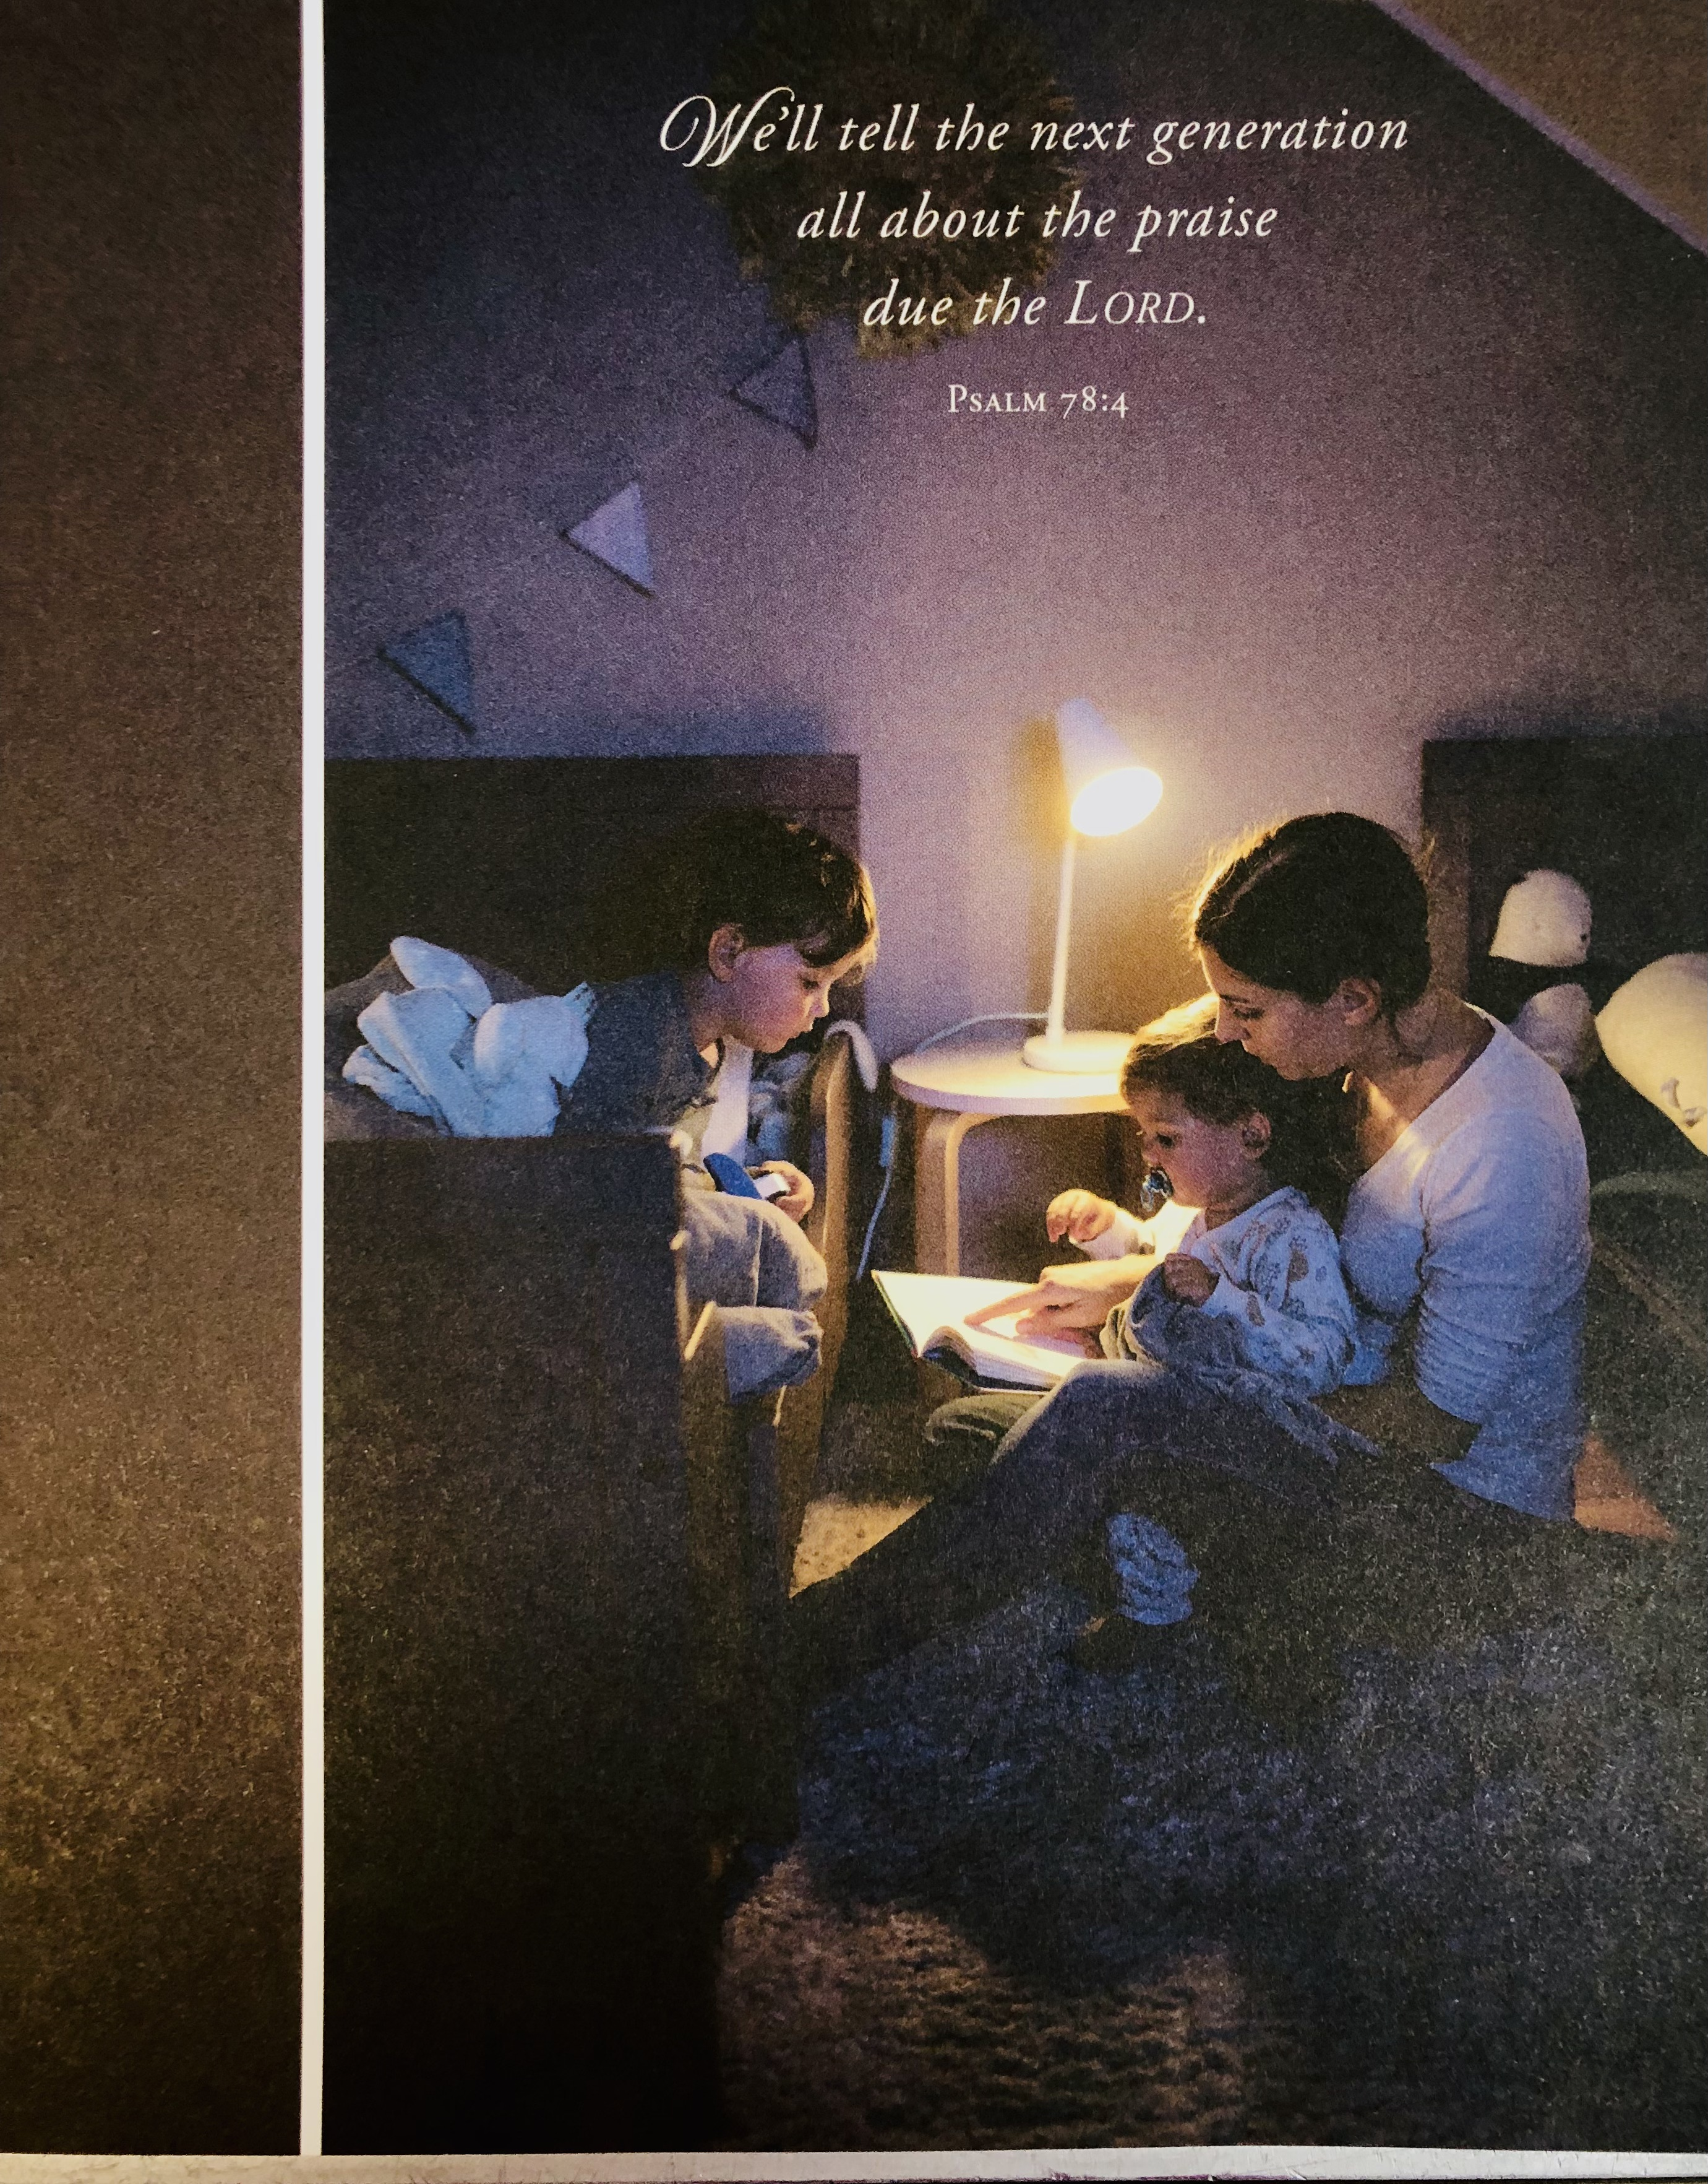

***“ Working Together with All to Connect to God’s Love”***

***“Working Together with All to Connect to God’s Love.”***

**Horseheads First United Methodist Church**

**Communion Sunday**

**October 1, 2023**

**Greeting and Announcements**

{as this service begins, please use the white prayer cards, on the pew back in front of you,

if you want something read aloud from the pulpit. During our first hymn, the Ushers will

collect cards to be read aloud.}

**Prelude** For the Bread Which You Have Broken              Ronald Arnatt

**\*Call to Worship**

L. Spirit of the Living God, fall afresh on us.

**P. As we gather in this place, allow your Spirit to fill our very being.**

L. As we worship this day, we remember our brothers and sisters who are worshipping elsewhere throughout the world.

**P. Inspire each of us to work more faithfully for justice and dignity of life everywhere.**

**All: Spirit of the Living God, fall afresh on us.**

**\*Hymn** I Come with Joy #617 UMH   

**\*Unison Prayer**

Our heavenly Father, we your humble children invoke your blessing on us. We adore you, whose name is love, whose nature is compassion, whose presence is joy, whose word is truth, whose Spirit is goodness, whose holiness is beauty, whose will is peace, whose service is perfect freedom, and in knowledge of whom stands our eternal life. Unto you be all honor and glory, through Jesus Christ our Lord. Amen.

**Joys and Concerns**

**Silent prayer**

**Pastoral prayer**

**Lord’s Prayer** [on screen] p.#895

**Gift of Music** At the Table of Our God                          Douglas Wagner             
 **Scripture:** **Exodus 17:1-7** p. 64

Leader: The word of God for the People of God

*People: Thanks be to God!*

**\*Hymn** Come, Thou Fount of Every Blessing #400 UMH  **Scripture: Matthew 21:23-32** p.#23-24

Leader: The word of God for the People of God

*People: Thanks be to God!*

**Sermon: The Author of Life**

**Communion:**  p.#23

**Communion Music:** Reverie                                                          Claude Debussy                 
 **\*Hymn:** This Is My Song #437 UMH

**\*Benediction**

[Please feel free to be seated and enjoy the Postlude}

**Postlude** Canzonetta                                              Dietrich Buxtehude

*indicates please stand, if able

               UMH = red hymnal

FWS =   black songbook

**FALL RUMMAGE SALE** to benefit missions.

**Horseheads 1st. United Methodist Church, 1034 W. Broad Street. Horseheads, NY**

Wednesday, October 4, 2023, 5:00pm – 8:00pm, Free dinner available

Thursday, October 5, 2023, 9:00am – 4:00pm, ½ price for each item purchased.

Friday, October 6, 2023, BAG SALE, 9:00am – Noon, $2.00 pr. Bag

BRING OWN BAGS NO PRE SALES

**RUMMAGE SALE GUIDELINES:**

We will have our Spring rummage sale with the following strict guidelines for people who would like to donate items:

1. No items to be brought to the church until Friday, September 29, 2023, after 10:00am.

2. DO NOT PUT ANYTHING IN THE CHURCH GARAGE OR LEAVE OUTSIDE THE CHURCH DOORS.

3. All items need to be clean and usable. This includes clothing, children’s items, kitchen items, etc.

4**. We will not accept TV’s, computer equipment, mattresses, bed pillows, clothes hangers**.

5. We cannot pick up large furniture – you need to take the items to the church.

RUMMAGE SALE DROP OFF DAYS AND TIMES

You can bring items on…

* Friday, September 29 after 10:00am
* Saturday, September 30, and Monday, October 2, from 9:00am – 4:00pm
* Tuesday, October 3, 9:00am – NOON **(no items accepted after noon)**

RUMMAGE SALE DROP OFF DAYS AND TIMES

You can bring items on Friday, September 29 after 10:00am

Saturday, September 30 and Monday, October 2, from 9:00am – 4:00pm

Tuesday, October 3, 9:00am – NOON (no items accepted after noon)

**Announcements 10/1/23**

***Flowers on the Altar are given to the Glory of God***

**Calendar**

10/4: Faith Builders, 6:30pm Sunday School at 10:45

10/4: Rummage Sale, 5-8pm Kindergarten-5th grade meeting in the Fellowship Hall (gym)

10/5: Rummage Sale, 9-3 Middle school/Confirmation: meeting in the Chapel

10/6: Rummage Sale, 9-12pm High school:  meeting in Room 18

10/6: Outreach, 6:30pm Parent Class: meeting in Room 21

Choir Practice on Saturday’s Adult Sunday School: Large Conference Room

at 3pm The Nursery is available for those 4 and under.

**Committee members** are needed for 2024 on worship, finance, church council.  See Pastor McDowell.

**Rummage Sale** – The donation list sign-up forms will be up for one more Sunday in the entranceway. There are still some items needed. Please take a moment on your way in or out of the Church vestibule and consider helping the kitchen volunteers.

**Sunday School at 10:45**

* **Kindergarten-5th grade** meeting in the Fellowship Hall (gym)
* **Middle school/Confirmation**: meeting in the Chapel, the confirmation class is focused on our spiritual journey of following Jesus Christ through membership in the church. This 14-week experience for grades 6-9 is interactive and taught by Pastor McDowell and Jamie Olcott in the chapel, 10:45-11:45 a.m. Sundays.
* **High school**:  meeting in Room 18, The senior high class is focused on God's relevance and accessibility in the 21st century. This year long journey for grades 9-12 is interactive and taught by Chad Miller and Karen Peterson in the youth room, 10:45-11:45 a.m. Sundays.
* **Parent Class:** meeting in Room 21
* **Adult Sunday School**: Large Conference Room
* **The confirmation class** is focused on our spiritual journey of following Jesus Christ through membership in the church. This 14-week experience for grades 6-9 is interactive and taught by Pastor McDowell and Jamie Olcott.

**HFRC is turning 15 years old!** We’ve been honored to partner with the church for all these years and we look forward to many more! We are planning a family-friendly celebration and fundraiser at the church on Friday, Oct. 13 from 5–8pm and we would love for you to celebrate this milestone with us! We will have a bounce house obstacle course, fun & games for the kids, along with food, drinks, & dessert. Tickets are available through our website: HorseheadsFamilyResourceCenter.org and in our playrooms starting Sept. 18. We hope to see you there!

**October 11th  Mid-Week Fellowship:** Mark and Deirdre Zimmerman are medical missionaries to Nepal who've been sent by the United Methodist Church (and supported by First Horseheads for some years). They've been in Nepal for around 30 years, and most recently Mark has been a physician / teacher at Patan Hospital while Deirdre has worked in dietetics both in Patan Hospital and in community-based nutrition. They left Nepal (for good) this past July and will come to share how God has led them through this journey.

Michael and Glenda Miller

Missionaries for Border Buddies Ministries Inc.

Tegucigalpa, Honduras

[http://www.borderbuddies.org](http://www.borderbuddies.org/)

**Dear Horseheads, UMC**, Glenda and I have been so blessed by your church in all the support that you have given us throughout the years. We haven't been home in almost four years and miss seeing everyone.  We will be hosting a Reconnection Tour and were wondering if you could announce these dates and the place when we will be presenting. Your Pastor and Congregation are welcome to come and worship, hear a message, and share a time of prayer together. This will empower us to see everyone in the nine days that we will be home.  Pastor Andy Pollock and his congregation at Fresh Start has graciously offered for us to use their Miracle Mile Campus at 2447 Elmira-Corning Rd. (the Miracle Mile) in Elmira Heights. If you have any questions or concerns, please contact Pastor Andy at: 585-483-5039 or email: [pastorandy@freshstartumc.com](mailto:pastorandy@freshstartumc.com)

**“Reconnection Tour”**

Place: Fresh Start Campus on the Miracle Mile

2447 Elmira-Corning Rd. (the Miracle Mile) in Elmira Heights.

When: October 2023

* Wednesday 18 -Thursday 19 - Friday 20
* Worship starts at: 6:30pm

**Karren's Clothing Cupboard**   Karren's Clothing Cupboard will no longer be open on Monday evenings, after a 3-month trial, we only had 1 visitor.  In the future, if we can find enough volunteers, we will open a couple of Saturdays a month.  Thank you to everyone that made this trail time possible.   The October sign-up sheet is in the airlock. We will be closed the week of rummage sale.

**Soup to Go**

We would like to thank everyone who donated to Sunday soups to go. Jamie Olcott and I enjoyed the last few years doing the soups and those who asked if they could help in any way. I believe we had a successful 2022 -2023 yr. Putting In the general fund $1129.00 but feeding over 163 people; hope this year will be just as successful.  If you have a soup you would like, let Jamie know and we will try and make it. October soup is loaded potato or Hank’s pumpkin soup. We will be starting up October 29 to March 24. Dates have been set so mark your calendar, 10/29,11/26,12/17 or 31, 1/28, 2/25, 3/24.

There is no set price, just a donation! Remember your neighbors who can’t get out or a friend you would like to share lunch with. Thank you and God Bless Jean Paul

**The November and December issue of the Upper Room is in the Narthex.**

**The October copy of the BRIDGE is also available in the Narthex.**